**Type 2 Liverpool Ringing Simulator**

02 – Build & Installation Guide

Author: Andrew Instone-Cowie

Date: 07 May 2025

Version: 1.8

Contents

Index of Figures 5

Index of Tables 7

Document History 8

Licence 10

Documentation Map 11

About This Guide 12

Typical Simulator Installation 13

What You Will Need 14

Skills 14

Tools 14

Parts 14

PCBs 15

JLCPCB or SeeedStudio 15

OSH Park 19

PCB Design Software Change 19

Simulator Assembly 20

Polarised Components 20

Voltage Regulators 20

Diodes 21

Electrolytic Capacitors 21

Integrated Circuits 22

LEDs 22

Magneto-Resistive Sensors 23

Simulator Interface Module 24

Parts List 24

Schematic 25

Parts 26

PCB Layout 26

Construction 27

Voltage Regulator 28

Power Module 31

Parts List 31

Schematic 32

Parts 33

PCB Layout 33

Construction 33

Magneto-Resistive Sensor Module 35

Parts List 35

Schematic 36

Parts 37

PCB Layout 37

Construction 37

Infra-Red & Other Sensor Modules 39

Parts List 39

Schematic 40

PCB Layout 41

Construction 41

Infra-Red Sensor 43

Enclosures 44

Parts List 44

Simulator Interface & Power Modules Enclosure 45

D Sub Serial Connector Alternative Drilling 46

Magneto-Resistive Sensor Module Enclosure 46

Infra-Red Sensor Module Enclosure 47

PCB Mounting Hardware 47

Grommets 48

Completed Assemblies 49

Simulator Interface Module 49

Power Module 49

Magneto-Resistive Sensor Module 50

Infra-Red Sensor Module 50

Firmware Upload 51

Hardware Programmer Options 52

Preparing the Environment 53

Preparing the Programmer 56

Setting the Fuses 60

Firmware Upload 65

Simulator Installation 67

Faculty Jurisdiction Rules 67

List B Application 67

Conditions 68

Simulator Interface Module 69

Power Module 69

Power Supply 70

Sensor Module Mounting 70

Magnet Mounting 72

Infra-Red Sensors 74

Reflector 74

Calibration 74

Cabling 75

Power/Data Cable 75

Sensor Cables 75

Computer Connection 76

Interface Module Setup 78

Connecting to the Interface Module 78

Worked Example 79

Sensor Channels 79

Example Installation 81

Default Settings 82

Disable Unused Channels 83

Re-Map Channels to Bells 84

Save Settings 85

Next Steps 86

Licensing & Disclaimers 87

Documentation 87

Software 87

Acknowledgements 88

# Index of Figures

Figure 1 – Documentation Map 11

Figure 2 – Simulator General Arrangement 13

Figure 3 – PCB Panels of Sensor Boards 15

Figure 4 – JLCPCB Upload Box 16

Figure 5 – JLCPCB File Uploaded 16

Figure 6 – JLCPCB Gerber Viewer 16

Figure 7 – JLCPCB Completed Order Form 18

Figure 8 – Voltage Regulator Orientation 20

Figure 9 – Diode Orientation 21

Figure 10 – Electrolytic Capacitor Orientation 21

Figure 11 – Integrated Circuit Orientation 22

Figure 12 – LED Orientation 22

Figure 13 – Magneto-Resistive Sensor Orientation 23

Figure 14 – Simulator Interface Parts 26

Figure 15 – Simulator Interface Board Layout 26

Figure 16 – Voltage Check Pin Locations 28

Figure 17 – Bending Voltage Regulator Pins 29

Figure 18 – Voltage Regulator Heatsink 29

Figure 19 – Completed Simulator Interface Module PCB 30

Figure 20 – Power Board Parts 33

Figure 21 – Power Board Layout 33

Figure 22 – Completed Power Module PCB 34

Figure 23 – Magneto-Resistive Sensor Demonstration 35

Figure 24 – Magneto-Resistive Sensor Board Parts 37

Figure 25 – Magneto-Resistive Sensor Board Layout 37

Figure 26 – Completed Magneto-Resistive Sensor Module PCB (Right-Handed) 38

Figure 27 – Generic Sensor Board Layout 41

Figure 28 – Completed Generic Sensor Module PCB 42

Figure 29 – Infra-Red Sensor Wiring 43

Figure 30 – Simulator Interface & Power Module Enclosure Drilling Guide 45

Figure 31 – Alternative Drilling Guide for DB9 Connector 46

Figure 32 – Magneto-Resistive Sensor Module Enclosure Drilling Guide 46

Figure 33 – Infra-Red Sensor Module Enclosure Drilling Guide 47

Figure 34 – PCB Mounting Hardware 47

Figure 35 – Grommets Drilled & Cut 48

Figure 36 – Completed Sensor Interface Module 49

Figure 37 – Completed Power Board 49

Figure 38 – Completed Magneto-Resistive Sensor Module 50

Figure 39 – Completed Infra-Red Sensor Module 50

Figure 40 – Examples of Hardware Programmers 52

Figure 41 – Arduino IDE Preferences Menu 53

Figure 42 – Arduino IDE Sketchbook Location 54

Figure 43 – Arduino IDE Boards Manager Menu 55

Figure 44 – Arduino IDE Board Manager 56

Figure 45 – Arduino USB Cable 56

Figure 46 – Arduino IDE ISP Sketch Loading 57

Figure 47 – Arduino Programmer Board Selection 58

Figure 48 – Arduino Programmer Port Selection 58

Figure 49 – Arduino IDE ISP Upload 59

Figure 50 – Programmer with Capacitor 60

Figure 51 – Programmer Connections 60

Figure 52 – Programmer Connected to Interface Board 61

Figure 53 – Arduino IDE Target Board Selection 62

Figure 54 – Arduino IDE Programmer Selection 63

Figure 55 – Arduino IDE Burn Bootloader 64

Figure 56 – Arduino IDE Add Library 65

Figure 57 – Arduino IDE Firmware Upload 66

Figure 58 – Installed Simulator Interface 69

Figure 59 – Installed Sensor (Lois Weedon 4th) 70

Figure 60 – Installed Sensor (Lois Weedon 6th) 71

Figure 61 – Installed Sensor (Chirk, Type 1) 71

Figure 62 – Magnet Mounting Dimensions 72

Figure 63 – Magnet Mounting Construction 73

Figure 64 – Completed Magnet Mounting 73

Figure 65 – Sensor Daisy Chain 75

Figure 66 – 9-Pin Serial Port 76

Figure 67 – 9-Pin Serial Cable 76

Figure 68 – PC USB Ports 77

Figure 69 – USB to Serial Adapter 77

Figure 70 – PuTTY Configuration Dialogue 78

Figure 71 – Display Interface Settings 79

Figure 72 – Interface Channel Numbers 80

Figure 73 – Example Sensor Cabling 81

Figure 74 – Example Channel Connections 81

Figure 75 – Disabled Channels 82

Figure 76 – Default Settings 82

Figure 77 – Disabling Channels Example 83

Figure 78 – Channel Re-Mapping Example 85

Figure 79 – Example Channel Connections 85

Figure 80 – Saving Interface Settings 86

# Index of Tables

Table 1 – PCB Ordering Parameters 17

Table 2 – Simulator Interface Module Parts List 24

Table 3 – Power Module PCB Parts List 31

Table 4 – Magneto-Resistive Sensor Module Parts List 35

Table 5 – Generic Sensor Module Parts List 39

Table 6 – Enclosures Parts List 44

Table 7 – Example Channel Mapping 84

Table 8 – Bell Numbers & Letters 84

# Document History

|  |  |  |  |
| --- | --- | --- | --- |
| **Version** | **Author** | **Date** | **Changes** |
| 0.1 | A J Instone-Cowie | 10/09/2018 | First Draft. |
| 0.2 | A J Instone-Cowie | 27/10/2018 | Minor corrections, PCB ordering, voltage regulator. |
| 0.3 | A J Instone-Cowie | 02/11/2018 | Changed Farnell 1N4001 part code for a more available UK stocked item. |
| 0.4 | A J Instone-Cowie | 24/01/2019 | Minor corrections, updated interface PCB to Rev D, added guidance on polarised components. |
| 0.5 | A J Instone-Cowie | 05/02/2019 | Replaced Amphenol RJHSE-5080-02 (no longer stocked by Farnell) with AMP TE Connectivity 5406526-1. Remove references to the Boardstuff programming shield, which is no longer available, and replace with examples of generic hardware programmers. |
| 0.6 | A J Instone-Cowie | 10/02/2019 | Add diagram identifying pins for voltage checks.  Add link to GitHub repository Issues log. |
| 0.7 | A J Instone-Cowie | 17/02/2019 | Correct diagram identifying pins for voltage checks. |
| 0.8 | A J Instone-Cowie | 24/02/2019 | Rev C Power Board: Updated OSH Park link and board render. |
| 0.9 | A J Instone-Cowie | 12/05/2019 | Add support for Second PC Board. |
| 0.10 | A J Instone-Cowie | 09/06/2019 | Updated interface PCB to Rev E, added ceramic resonator as part of fix for Issue #3.  Added link to JLCPCB PCB manufacturer. |
| 1.0 | A J Instone-Cowie | 03/08/2019 | First Release. Updated Power Board to Rev D, Second PC to Rev B, both with improved surge protection. Remove OSH Park permalinks,  Fixed dimension error on IR sensor enclosure. Add reference to enclosure drilling templates. |
| 1.1 | A J Instone-Cowie | 30/09/2019 | Moved Second PC Board to new Multi-PC Guide. |
| 1.2 | A J Instone-Cowie | 18/08/2020 | Minor update. |
| 1.3 | A J Instone-Cowie | 22/07/2021 | Add notes about Faculty Jurisdiction, remove references to COVID-19. |
| 1.4 | A J Instone-Cowie | 27/08/2021 | Alternative DB9 enclosure drilling option, DB9 part. |
| 1.5 | A J Instone-Cowie | 19/06/2024 | Minor text updates, update faculty links, update external links. |
| 1.6 | A J Instone-Cowie | 27/06/2024 | Updated Farnell/CPC/Screwfix part numbers, update PCB ordering information. |
| 1.7 | A J Instone-Cowie | 28/08/2024 | Improve diagram following feedback. |
| 1.8 | A J Instone-Cowie | 07/05/2025 | Eagle to KiCad PCB design tool migration. Updated schematics and board layouts (except MR sensor). |

*Copyright ©2018-25 Andrew Instone-Cowie.*

*Cover photograph: A completed Type 2 Simulator Interface Board.*

*PC ports vector graphic design by <https://www.vecteezy.com>  
(Vecteezy Standard Licence, Free for personal and commercial use with attribution.)*

# Licence

**

*This work is licensed under a Creative Commons Attribution-ShareAlike 4.0 International License.[1]*

*Unless otherwise separately undertaken by the Licensor, to the extent possible, the Licensor offers the Licensed Material as-is and as-available, and makes no representations or warranties of any kind concerning the Licensed Material, whether express, implied, statutory, or other. This includes, without limitation, warranties of title, merchantability, fitness for a particular purpose, non-infringement, absence of latent or other defects, accuracy, or the presence or absence of errors, whether or not known or discoverable. Where disclaimers of warranties are not allowed in full or in part, this disclaimer may not apply to You.*

*To the extent possible, in no event will the Licensor be liable to You on any legal theory (including, without limitation, negligence) or otherwise for any direct, special, indirect, incidental, consequential, punitive, exemplary, or other losses, costs, expenses, or damages arising out of this Public License or use of the Licensed Material, even if the Licensor has been advised of the possibility of such losses, costs, expenses, or damages. Where a limitation of liability is not allowed in full or in part, this limitation may not apply to You.*

# Documentation Map

Figure 1 – Documentation Map

# About This Guide

The Type 2 Liverpool Ringing Simulator allows sensors, attached to one or more real tower bells or teaching dumb bells, to be connected to a computer Simulator Software Package such as Abel[2], Beltower[3] or Virtual Belfry[4]. This allows you to extend and augment the teaching and practice opportunities in your tower.

The simulator is modular. This ***Build & Installation Guide*** shows you how to build and install the Simulator Interface module, Power module and Sensor modules hardware, install it in the tower, and set it up ready for your chosen Simulator Software Package.

In this guide you will find:

* Parts lists and schematics.
* Detailed construction and configuration information.
* Links to suggested sources of parts, including ready-made printed circuit boards and cables.
* Links to download the associated firmware source code, PCB CAD files and other supporting data hosted on GitHub.
* Guidance on installing the simulator hardware in the tower.

Configuration guides for the main Simulator Software Packages are available separately, as is a detailed ***Technical Reference Guide***.

The ***Multi-PC Guide*** contains information on building the Second PC module or the Basic Serial Splitter module to allow multiple PCs to be used concurrently. If you are planning to run multiple PCs, it is strongly recommended that you complete and test the core Simulator modules first (Power, Interface, Sensors), before moving on to build the multiple PC modules.

Please note that this is a Build-it-Yourself project. No pre-built hardware is available.

# Typical Simulator Installation

The following diagram illustrates the general arrangement of a Simulator installation using a sensor aggregation hardware interface like the Liverpool Ringing Simulator.

Multiple Sensor modules in the belfry, one per bell, are connected to a Simulator Interface module. A single data cable transmits the aggregated signals from the Simulator Interface module to the Simulator PC in the ringing room. The same cable feeds power from a low voltage power supply in the ringing room back up to the Simulator Interface to power both Interface and Sensor modules. The Type 2 simulator supports up to 16 sensors.

In the ringing room, a PC runs a Simulator Software Package which interprets the received signals and turns them into the simulated sound of bells.

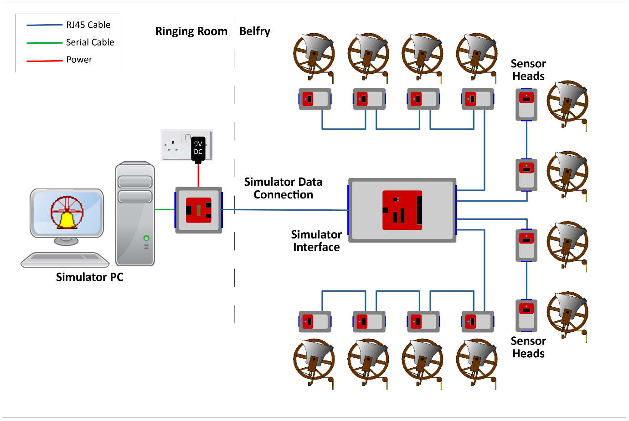

Figure 2 – Simulator General Arrangement

This guide provides detailed build and installation information for the Simulator Interface module, Power module and the Sensor modules. As an option, multiple Simulator PCs may be used concurrently; the options and setup for this are described in the separate ***Multi-PC Guide***.

# What You Will Need

## Skills

The Liverpool Ringing Simulator is a Build-it-Yourself project. Based on feedback from constructors, the Type 2 simulator has been re-designed to be easier to construct and install than the original version, particularly around the cabling and enclosures.

Some prior experience of soldering and basic electronics kit construction will be helpful before you build the Type 2 Liverpool Ringing Simulator, but there is nothing complex in the design, and there are no surface mount components or cables to solder.

The ability to make simple voltage and resistance measurements with a multimeter will be helpful in troubleshooting, but more advanced diagnostic equipment is not required.

## Tools

* A small soldering iron suitable for electronics use – around 15 Watts is fine.
* Fine rosin-cored electronics solder – NOT plumbers’ acid core solder.
* A small pair of side cutters.
* A small pair of needle nose pliers
* A 20mm hole saw & arbor (eg Screwfix parts 22647 & 7518H).
* A sharp utility knife.
* A 4.5mm drill bit.
* An electric drill – a bench mounted drill is best, but a hand-held drill can be used with care.
* Optional for optical sensors: An 18mm hole saw (eBay).
* Recommended: A basic multimeter with DC voltage and resistance ranges.

## Parts

With the demise of Maplin, availability of electronic components from high street stores has been drastically reduced, and you will almost certainly need to source parts online. Suggested online suppliers include Farnell (and their CPC consumer division – particularly useful for cables) and Rapid Electronics. Parts may also be sourced from reputable suppliers on eBay.

* Farnell – <https://uk.farnell.com>
* CPC – <https://cpc.farnell.com>
* Rapid Electronics - <https://www.rapidonline.com>
* eBay – <https://www.ebay.co.uk>

Where possible, Farnell or CPC part numbers have been given. Note that some smaller parts will only be available in larger quantities than are required for a single simulator. You may want to use the leftovers to build more simulators for other local towers.

## PCBs

**Surplus development PCBs may be available from the Liverpool Ringing Simulator Project, please enquire about availability via the contact form on the website.**

The core Type 2 simulator modules use three or four basic types of PCB[5]:

* Simulator Interface Board – 1 required per installation
* Power Board – 1 required per installation
* Sensor Boards – 1 required per bell, per installation

Suggested sources of PCBs are JLCPCB and SeeedStudio in China, and OSH Park in the USA. All take typically around three weeks to deliver PCBs to the UK at lowest shipping cost, expedited options are available. PCB design files, known as “Gerber files”, are available from the project GitHub repository:

* <https://github.com/Simulators/simulator-type2>

### JLCPCB or SeeedStudio

The most cost-effective way of obtaining PCBs is to order them from a Chinese PCB fabrication house, such as JLCPCB, or SeeedStudio’s “Fusion PCB” service. At the time of writing, 5 PCBs[6] of a single design are available for as little as $2.00 US, plus postage[7].

The smaller Power and Sensor boards are designed as “panels” each containing multiple boards, four Power Boards or six Sensor Boards per panel. Each panel is treated as a single PCB by the fabricator, further reducing the total cost, so for example an order of 5 PCBs will result in enough boards for 30 sensors.

The following photograph shows panels of six Sensor Boards manufactured by SeeedStudio. These can easily be split into separate boards.

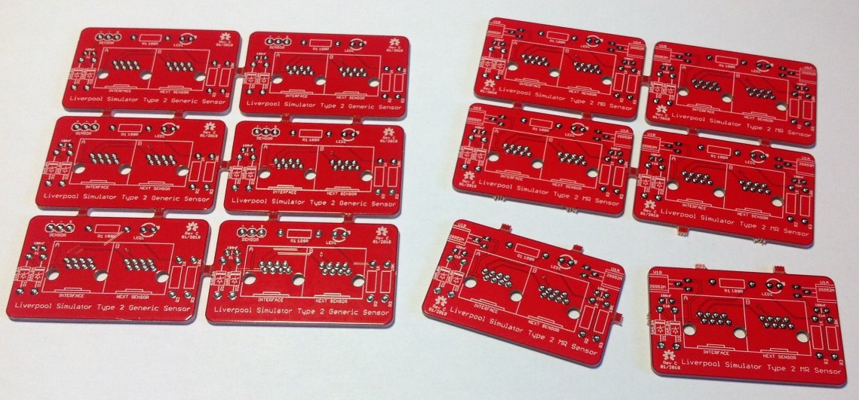

Figure 3 – PCB Panels of Sensor Boards

To order from JLCPCB or SeeedStudio, download the Gerber files[8] from the project GitHub repository, then browse the following link to the service:

* <https://jlcpcb.com>
* <https://www.seeedstudio.com/fusion_pcb.html>

The ordering website for both manufacturers looks very similar, so only one (JLCPCB) is shown in the following examples.

For each zipped Gerber file in turn, upload by clicking the *Add Gerber Files* button, complete the order form, and add the boards to the shopping cart. Repeat the process with the Gerber file for each type of board you want to order. Before confirming each board, use the online Gerber Viewer to check that the board looks as it should. Follow the *Gerber Viewer* link in the upload box.

Figure 4 – JLCPCB Upload Box

Figure 5 – JLCPCB File Uploaded

Figure 6 – JLCPCB Gerber Viewer

Return to the order form and complete it using the parameters below. Note that the parameters for the smaller, panelised boards are slightly different from the larger, single boards.

Table 1 – PCB Ordering Parameters

|  |  |  |  |
| --- | --- | --- | --- |
| **Form Field** | **Interface or Serial Splitter Boards** | **Power or Second PC Boards (4-way Panelised)** | **MR or Generic Sensor Boards (6-way Panelised)** |
| Base Material | FR-4 | | |
| Layers | 2 | | |
| Dimensions | (Automatically detected from uploaded file) | | |
| PCB Qty | 5 | | |
| Product Type | Industrial/Consumer (default) | | |
| Different Design | 1 | | |
| Delivery Format | Single PCB | Panel by Customer | Panel by Customer |
| Panel Format Columns | N/A | 2 | 2 |
| Panel Format Rows | N/A | 2 | 3 |
| PCB Thickness | 1.6mm (default) | | |
| PCB Colour | Red | | |
| Silkscreen | White (default) | | |
| Surface Finish | HASL (with Lead) (default)[9] | | |
| Outer Copper Weight | 1oz (default) | | |
| Via Covering | Tented (default) | | |
| Board Outline Tolerance | ±0.2mm (default) | | |
| Confirm Production File | No (default) | | |
| Remove Order Number | No (default) | | |
| Flying Probe Test | Fully Test (default) | | |
| Gold Fingers | No (default) | | |
| Castellated Holes | No (default) | | |
| Edge Plating | No (default) | | |

An example of a completed JLCPCB order form (for an Interface Board) is shown below:

Figure 7 – JLCPCB Completed Order Form

* The *PCB Dimensions* should be detected automatically from the uploaded file.
* The *Number of Different Designs* is always 1, even for the panelised PCBs.
* All other settings should be as shown above.

### OSH Park

PCBs can be obtained from the OSH Park service in the USA, and links to each board type are listed below. OSH Park produce very high quality “ENIG finish” boards, and currently charge $5 (US) per square inch for three copies of a single type of board, including international airmail shipping.

Do NOT try to order panelised PCBs from OSH Park using the panelised Gerber files! There is no cost advantage to doing so, and as OSH Park are themselves a panelisation service, trying to order panelised PCBs will most likely result in your order being rejected.

To order from OSH Park, download the Gerber files[10] from the project GitHub repository, then browse the following link to the service and follow the instructions:

* <https://oshpark.com>

### PCB Design Software Change

The Cadsoft Eagle design tool, now owned by AutoDesk, and originally used for all Liverpool Ringing Simulator Project PCBs, is being discontinued. As of May 2025, PCB designs have been migrated to the open source KiCad EDA package, and KiCad CAD files and KiCad-generated Gerber files have been made available in the GitHub repository.

The project documentation has also been updated with schematics and PCB layouts generated by KiCad, but board photographs may continue to show boards designed using Eagle. There may be cosmetic differences between the Eagle and KiCad versions of PCBs, but the functionality of the first KiCad and final Eagle versions of boards will be the same, except where noted otherwise.

# Simulator Assembly

This section describes the assembly of the Simulator Interface module, Power module, and the Sensor modules. It also covers the suggested enclosures.

Before you start construction of the Simulator hardware, check the ***Release Notes*** and the issues log on the project GitHub repository for any open or late-breaking issues which may affect your build:

* <https://github.com/Simulators/simulator-type2/issues>

It is recommended to give the completed Simulator Interface and Sensor PCBs a coat of protective spray lacquer on both sides before installation, as a protection against damp. A suitable lacquer is Ambersil Acrylic Conformal Coating (Farnell 1666251). Protect the connectors **and the ceramic resonator** with masking tape before spraying.

## Polarised Components

Several of the components of the Simulator are polarised and must be fitted the right way round for correct operation. Guidance is given below on correct orientation of the polarised components, but if in any doubt consult the component supplier or the manufacturer’s data sheets. Fitting a polarised component the wrong way round may result in damage to the component.

### Voltage Regulators

The standard voltage regulator is fitted to the PCB with the metal tab flat against the surface of the board. The alternative Traco Power TSR 1-2450 regulator has pin 1 indicated with a white dot. If used, the alternative regulator must be fitted so that pin 1 is closest to the edge of the board, as shown in the following photograph.

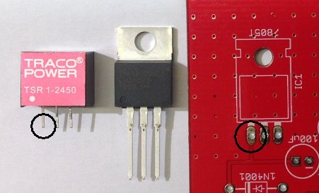

Figure 8 – Voltage Regulator Orientation

### Diodes

The cathodes of the 1N4001 and SA5.0A diodes are indicated by a white band on the packages. The diodes must be fitted so that the white band aligns with the corresponding white band printed on the PCB, as shown in the following photograph.

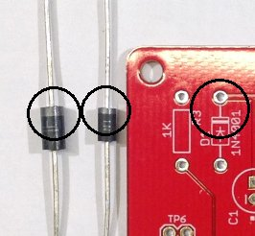

Figure 9 – Diode Orientation

### Electrolytic Capacitors

The negative side of electrolytic capacitors is usually indicated by a shorter lead, and by negative markings on the side of the component. The electrolytic capacitors must be fitted with the negative lead through the hole marked with the corresponding negative sign and white dot printed on the PCB, as shown in the following photograph.

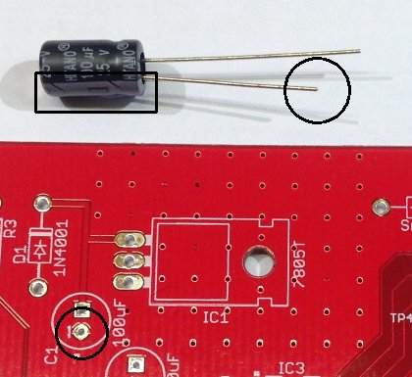

Figure 10 – Electrolytic Capacitor Orientation

### Integrated Circuits

The two integrated circuits have pin 1 marked with a dot, and/or a notch in the end of the package. The ICs must be fitted with the notch/dot aligned with the notch and white dot printed on the PCB, as shown in the following photograph.

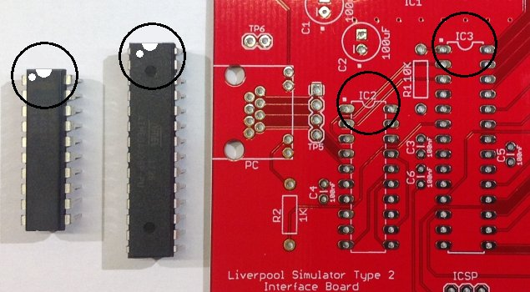

Figure 11 – Integrated Circuit Orientation

### LEDs

The cathode of the LEDs is usually indicated by a shorter lead, and/or by a flat on the side of the plastic flange. The LEDs must be fitted with the cathode through the hole marked with the corresponding white dot printed on the PCB, as shown in the following photograph.

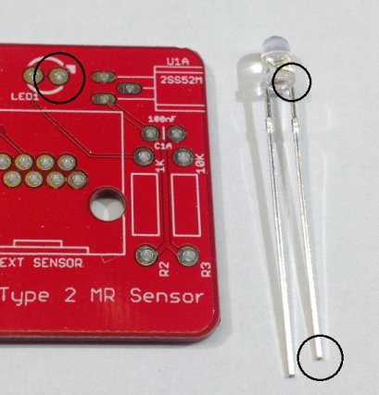

Figure 12 – LED Orientation

### Magneto-Resistive Sensors

The magneto-resistive sensors are mounted flat on the PCB, with the chamfered and printed side uppermost, as shown in the following photograph.

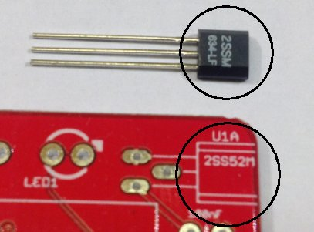

Figure 13 – Magneto-Resistive Sensor Orientation

## Simulator Interface Module

The Simulator Interface module contains the power supply for the interface and Sensor modules, the microcontroller, a RS-232 serial line driver, plus power and diagnostic LEDs, and an ICSP[11] programming interface for firmware upload.

### Parts List

Table 2 – Simulator Interface Module Parts List

|  |  |  |
| --- | --- | --- |
| **Reference** | **Component** | **Notes** |
| PCB | Type 2 Simulator Interface PCB |  |
| R1 | 10kΩ 0.25W Metal Film | Farnell 9341110 |
| R2, R3 | 1kΩ 0.25W Metal Film | Farnell 9341102 |
| C1, C2 | 100µF 25V Electrolytic (6.3mm Radial) | Farnell 9451188 |
| C3, C4, C5, C6 | 100nF (0.1µF) 50V MLCC[12] (2.54mm Radial) | Farnell 1457655 |
| D1 | 1N4001 | Farnell 1458986 |
| D2 | SA5.0A | Farnell 1886342 |
| IC1 | MC7805CTG (replacement for LM7805) (Alternative: Traco Power TSR 1-2450) | Farnell 9666095 (Farnell 1696320) |
| IC2 | MAX233EPP+G36 | Farnell 2519158 |
| IC3 | ATmega328P-PU | Farnell 1715487 |
| Q1[13] | Murata 8MHz Resonator CSTLS8M00G53-A0 | Farnell 2443273 |
| PC Connector | Amphenol RJHSE-5084 | Farnell 1860578 |
| Sensors Connector | Amphenol RJHSE-5080-04 | Farnell 2709010 |
| ICSP Header[14] | 2x3-pin 0.1” Male Header | Farnell 1593440 |
| IC Socket | 20-pin, 0.3” pitch | Farnell 4285608 |
| IC Socket | 28-pin, 0.3” pitch | Farnell 2445626 |
| Hardware | M3 Bolt (6mm/9mm) Nut, & Washer | Use 9mm if fitting a heatsink |
| Heatsink | TO-220 Heatsink (Optional) | Farnell 1703172 |

### Schematic

### Parts

The following photograph shows the complete set of parts required for the Simulator Interface PCB.

Figure 14 – Simulator Interface Parts

### PCB Layout

The following diagram shows the layout of the Simulator Interface PCB. All components are mounted on the top (silkscreen) side of the board.

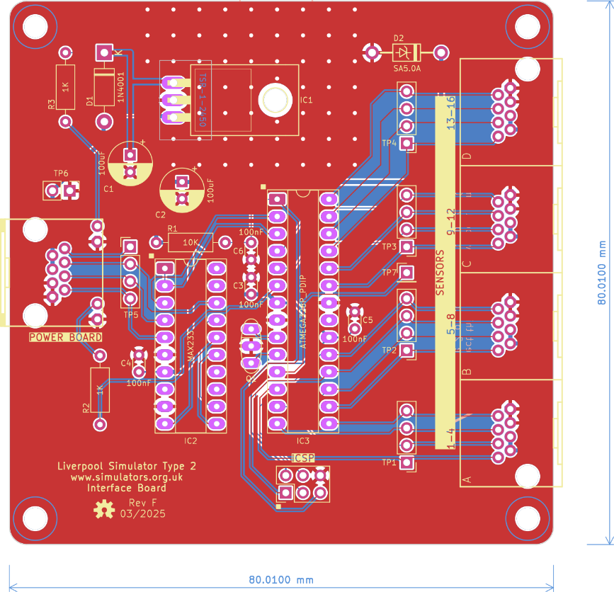

Figure 15 – Simulator Interface Board Layout

### Construction

All the components on the Simulator Interface module are mounted on top, silkscreen, side of the board.

* Start by soldering the components with the lowest profile (resistors, ceramic capacitors), then the remainder of the components in order of increasing height, ending with the RJ45 sockets.
* The use of IC sockets for IC2 & IC3 is strongly recommended.
* When fitting the voltage regulator, carefully bend the pins through 90 degrees, as described below, so that the mounting hole in the tab lines up with the mounting hole in the PCB. Secure the regulator to the board with an M3 nut, bolt and washer before soldering the pins. A tiny smear of heatsink compound between the tab and board will improve heatsinking.
* There is no need to fit pins to any of the test point holes TP1 – TP7.
* If you plan to upload the firmware to the microcontroller in-situ using the method described below, fit the 2 x 3-pin ICSP header pins. These can be omitted if you are using a separate programmer or have obtained a microcontroller with the firmware already loaded.
* For high current installations, i.e. those with large numbers of optical sensors and/or very short power/data cable runs, consider replacing the linear regulator with a switched buck regulator such as the Traco Power TSR 1-2450. This is a direct drop-in replacement for the standard TO-220 package regulator. The buck regulator is much more efficient than the linear version, and reduces the heat dissipation.
* A small heatsink may be required for the voltage regulator, particularly in larger installations with higher current (e.g. optical) sensors. Consider using a buck regulator instead. A heatsink is not generally required for installations using the lower current magneto-resistive sensors.
* Before fitting the socketed ICs, connect the board to a power supply (using the Power Board and a short RJ45 cable) and check using a multimeter that the supply voltage appears on the pins of TP6, and that +5V and 0V appear on the correct pins of the IC sockets. The pins are identified in the diagram below. The green power LED in the “PC” RJ45 connector should also light. Disconnect the power supply and fit the ICs.

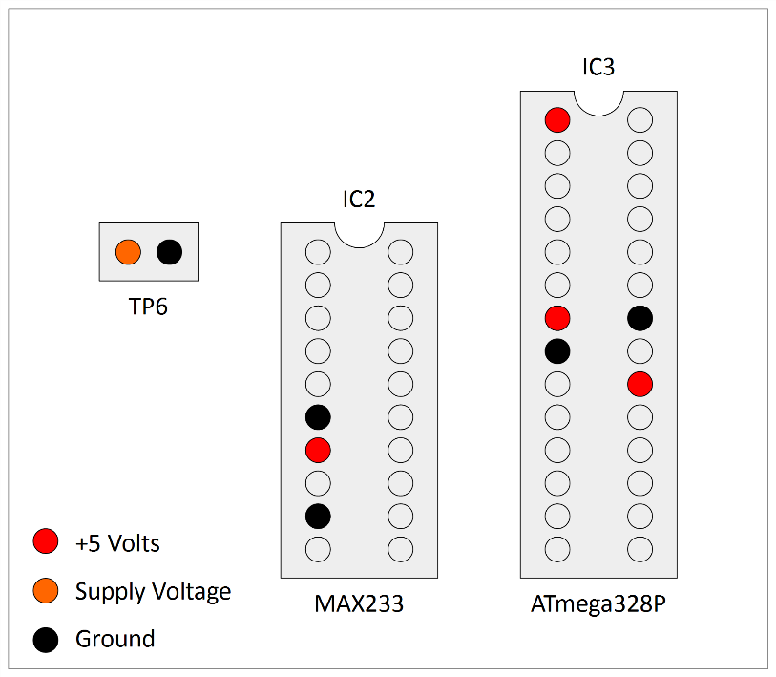

Figure 16 – Voltage Check Pin Locations

* If the board is powered up at this point with no firmware installed on the microcontroller, there will be no indication from the yellow diagnostic LED. This is normal.
* Pay close attention to the correct orientation of the polarised components D1, D2, C1, C2, IC1, IC2 & IC3.
* The mounting lugs of the RJ45 connectors clip into the holes in the PCB. Make sure the connector pins are correctly aligned with the holes before clipping the connector into the board, and then soldering the pins.
* Note that the connectors overhang the edges of the PCB slightly. This is intentional and is to allow for the board to be fitted into to a case in future.

### Voltage Regulator

#### Bending Pins

The Simulator Interface Board PCB includes an alignment jig to assist you in bending the voltage regulator pins accurately[15].

* Bolt the voltage regulator to the reverse side of the board, at 90 degrees to its final position, so that the pins hang over the edge of the board.
* Support the pins close to the body of the voltage regulator with a matchstick, and then bend the pins carefully through 90 degrees, using the edge of the PCB as a guide.
* Fit the voltage regulator to the right side of the PCB, and the pins and fixing hole should be properly aligned.
* Bolt the voltage regulator to the PCB before soldering the pins.
* The process is illustrated in the following photograph.

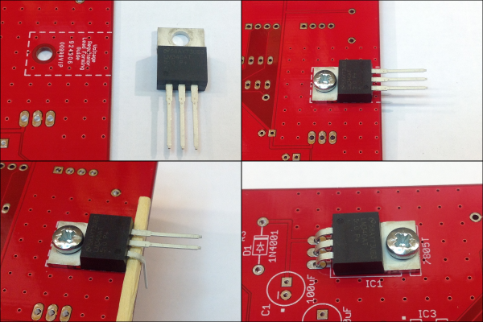

Figure 17 – Bending Voltage Regulator Pins

#### Heatsink

If you are fitting an additional heatsink to the voltage regulator, bolt the voltage regulator and heatsink to the PCB before soldering the pins. Make sure that the heatsink is not touching the PCB solder pads for the voltage regulator pins. A 9mm M3 bolt is required if fitting a heatsink.

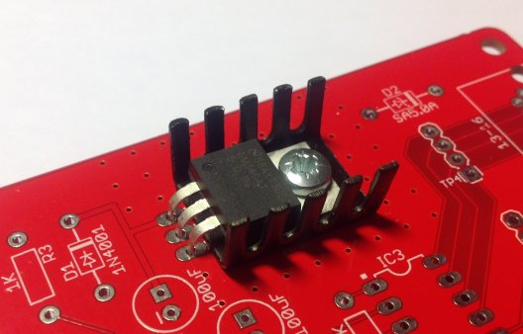

Figure 18 – Voltage Regulator Heatsink

A completed Simulator Interface Board PCB is shown in the following photograph.

Figure 19 – Completed Simulator Interface Module PCB

## Power Module

The Power module is intended to be located close to the Simulator PC and enables the PC serial port (or a USB-Serial adapter), and the power supply, to be connected to the power/data cable which runs up to the Simulator Interface in the belfry. It also provides a protective fuse, and surge protection diodes on the power and serial lines.

### Parts List

Table 3 – Power Module PCB Parts List

|  |  |  |
| --- | --- | --- |
| **Reference** | **Component** | **Notes** |
| PCB | Type 2 Power Board PCB |  |
| PC Connector | Right Angle PCB D Sub Connector 9 Pin | Farnell 1848372* |
| Interface Connector | Amphenol RJHSE-5080 | Farnell 1860577 |
| Power Connector | DC Power Connector 5mm PCB Mount | Farnell 1854512 |
| Fuse Holder | 20mm PCB Mount Fuse Holder | Farnell 2461158 |
| Fuse | 20mm 800mA Quick Blow Fuse | Farnell 2461215 |
| D1 | SA12A | Farnell 2679618 |
| D2, D3, D4 | SA15CA | Farnell 2762809 |

(* Farnell part 1848372 has threaded screw lock posts for cable plugs fitted with locking screws. If you do not want these, use alternative part 1084701 instead.)

### Schematic

### Parts

The following photograph shows the complete set of parts required for the Power Board PCB.

Figure 20 – Power Board Parts

### PCB Layout

The following diagram shows the layout of the Power Board PCB. All components are mounted on the top (silkscreen) side of the board.

Figure 21 – Power Board Layout

### Construction

All the components on the Power module are mounted on top, silkscreen, side of the board.

* If your Power Board came from a panelized PCB, lightly file down any remaining nibs from the edges of the board.
* Start by soldering the components with the lowest profile, then the remainder of the components in order of increasing height.
* Pay close attention to the correct orientation of the polarised diode D1. D2, D3 & D4 are not polarised.
* There is no need to fit pins to the test point holes TP1 – TP2.
* Fit a 20mm 800mA quick blow fuse to the fuse holder.
* Note that the connectors overhang the edges of the PCB slightly. This is intentional and is to allow for the board to be fitted into to a case in future.

A completed Power Board PCB is shown in the following photograph.

Figure 22 – Completed Power Module PCB

## Magneto-Resistive Sensor Module

The magneto-resistive sensor module, which is based on a design[16] by Aidan Hedley, uses a Honeywell magneto-resistive sensor IC[17], activated by a small, powerful rare earth magnet mounted on the wheel shroud. This sensor has no moving or optical parts and is completely free of optical interference. It also draws much less current than most optical sensors.

Using a magnet of the type suggested below, the absolute maximum operating distance of the prototype is approximately 60mm (face of magnet to face of sensor). In practice a maximum operating distance of approximately 30-40mm is recommended.

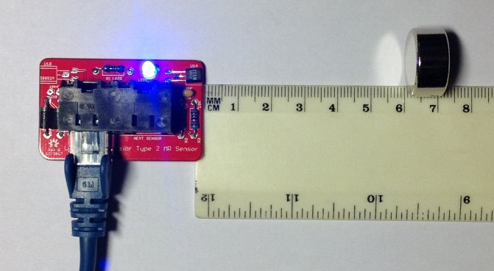

Figure 23 – Magneto-Resistive Sensor Demonstration

The sensor PCB contains all the components of the sensor, including the magneto-resistive sensor itself, a diagnostic LED, and associated components. Build one sensor PCB for each bell you want to connect to the simulator.

### Parts List

Table 4 – Magneto-Resistive Sensor Module Parts List

|  |  |  |
| --- | --- | --- |
| **Reference** | **Component** | **Notes** |
| PCB | Type 2 Magneto-Resistive Sensor PCB |  |
| R1 | 100Ω 0.25W Metal Film | Farnell 9341099 |
| R2 | 1kΩ 0.25W Metal Film | Farnell 9341102 |
| R3 | 10kΩ 0.25W Metal Film | Farnell 9341110 |
| C1 | 100nF (0.1µF) 50V MLCC (2.54mm Radial) | Farnell 1457655 |
| LED1 | Blue 3mm | Farnell 1863182 |
| D1, D2 | SA5.0A | Farnell 1886342 |
| IC1 | Honeywell 2SS52M | Farnell 3111519 |
| Connector | AMP TE Connectivity 5406526-1[18] | Farnell 2452587 |
| Operating Magnet | N52 grade, 20mm x 10mm Neodymium |  |

### Schematic

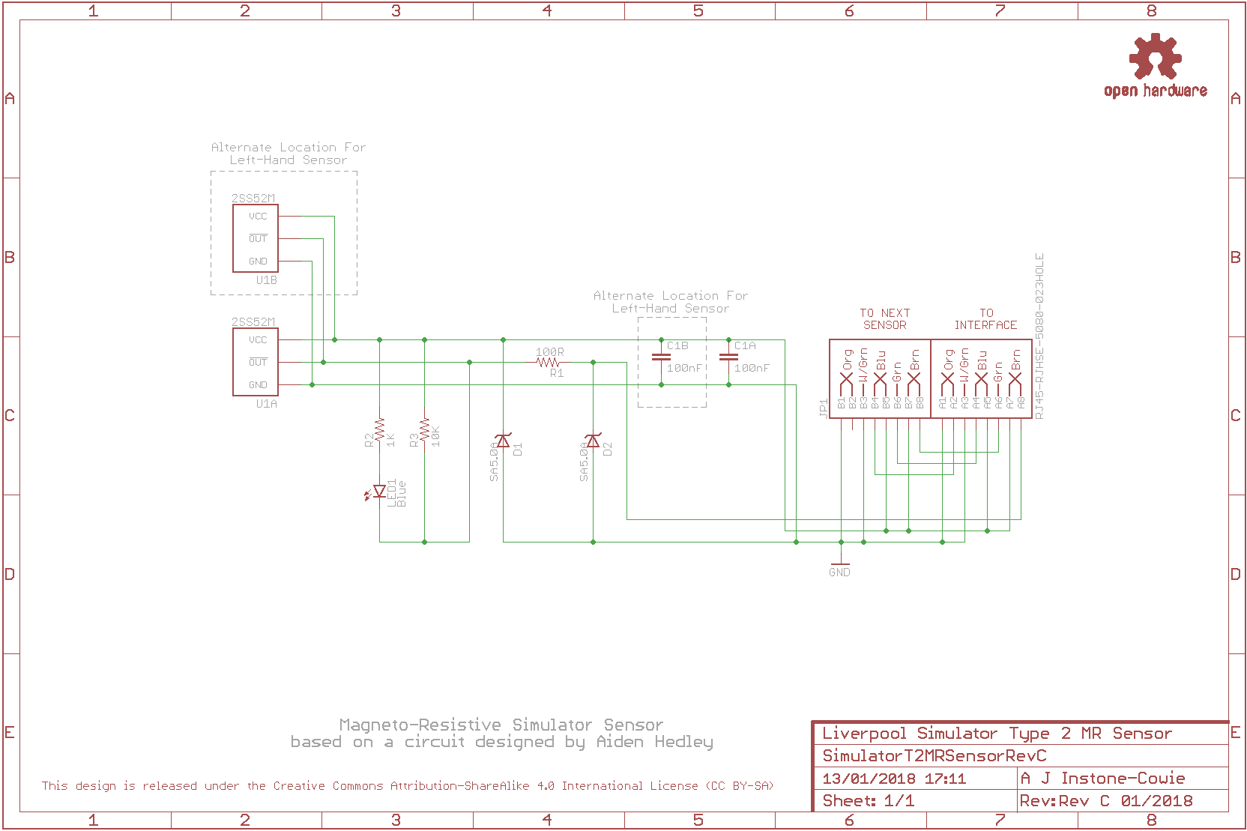

### Parts

The following photograph shows the complete set of parts required for one Magneto-Resistive Sensor Board.

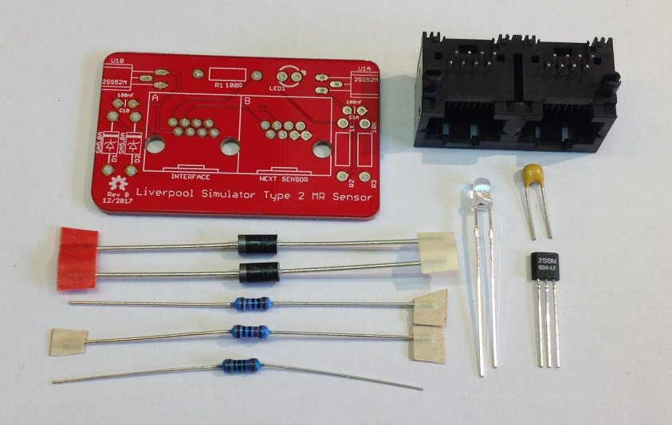

Figure 24 – Magneto-Resistive Sensor Board Parts

### PCB Layout

The following diagram shows the layout of a Magneto-Resistive Sensor PCB. All components are mounted on the top (silkscreen) side of the board.

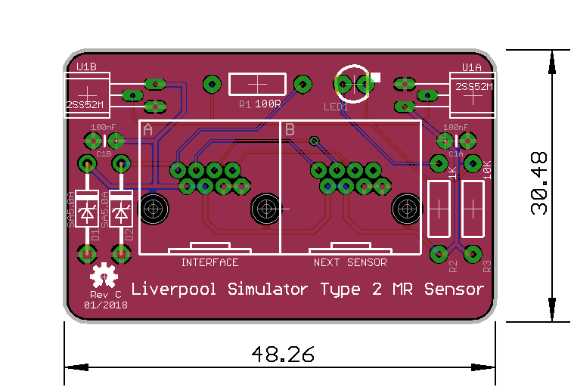

Figure 25 – Magneto-Resistive Sensor Board Layout

### Construction

All the components on the Magneto-Resistive Sensor module are mounted on top, silkscreen, side of the board.

* If your Sensor Board came from a panelized PCB, lightly file down any remaining nibs from the edges of the board. The board is intended to be a close fit in the suggested enclosure.
* Sensors can be constructed as right-handed or left-handed, to suit the installation in the belfry. Fit sensor U1 and capacitor C1 at positions U1A/C1A for a right-handed sensor (as shown in the pictures in this section), or at U1B/C1B for a left-handed sensor.
* Start by fitting the sensor IC. Carefully bend the pins through 90 degrees using needle nose pliers, so that the sensor sits flat against the PCB, with the end of the sensor flush with the edge of the board.
* Then solder the remaining components, starting with those with the lowest profile (resistors, ceramic capacitors), then the remainder of the components in order of increasing height, ending with the RJ45 socket.
* Pay close attention to the correct orientation of the polarised components D1, D2, U1, LED1.
* The mounting lugs of the RJ45 connector clip into the holes in the PCB. Make sure the connector pins are correctly aligned with the holes before clipping the connector into the board.
* There is an additional mounting hole in the PCB which allows for the dual RJ45 connector to be replaced with a single RJHSE-5080 version in the “Interface” position. This is optional and intended for a sensor to be located at the end of a chain of sensors. To allow for maximum flexibility when cabling the sensors, you may choose to fit dual connectors to all sensor boards.

A completed right-handed Magneto-Resistive Sensor PCB is shown in the following photograph.

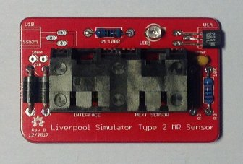

Figure 26 – Completed Magneto-Resistive Sensor Module PCB (Right-Handed)

## Infra-Red & Other Sensor Modules

The Generic Sensor module is designed to allow other types of sensor to be connected to the simulator interface, provided these are electrically compatible with the system[19]. It can also be used to build alternative infra-red sensors similar to those used in the original Liverpool Ringing Simulator.

### Parts List

Table 5 – Generic Sensor Module Parts List

|  |  |  |
| --- | --- | --- |
| **Reference** | **Component** | **Notes** |
| PCB | Type 2 Generic Sensor PCB |  |
| R1 | 100Ω 0.25W Metal Film | Farnell 9341099 |
| R2 | 1kΩ 0.25W Metal Film | Farnell 9341102 |
| R3 | 10kΩ 0.25W Metal Film | Farnell 9341110 |
| C1 | 100nF (0.1µF) 50V MLCC (2.54mm Radial) | Farnell 1457655 |
| LED1 | Yellow 3mm | Farnell 2112098 |
| D1, D2 | SA5.0A | Farnell 1886342 |
| Sensor Header | 1x3-pin 0.1” Male Header (cut from a longer strip) | Farnell 1462888 |
| Connector | AMP TE Connectivity 5406526-1[20] | Farnell 2452587 |
| Infra-Red Sensor | E18-D80NK Infra-Red Obstacle Sensor | Hobby Components[21] 4tronix[22] |

### Schematic

### PCB Layout

The following diagram shows the layout of a Generic Sensor PCB. All components are mounted on the top (silkscreen) side of the board.

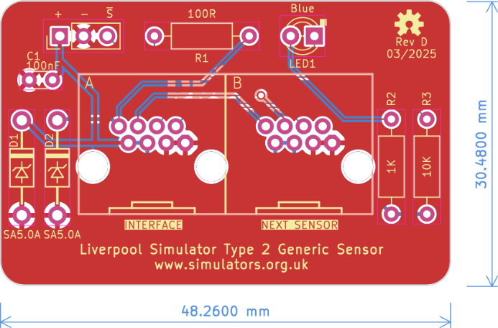

Figure 27 – Generic Sensor Board Layout

### Construction

All the components on the Generic Sensor module are mounted on top, silkscreen, side of the board.

* If your Sensor Board came from a panelized PCB, lightly file down any remaining nibs from the edges of the board. The board is intended to be a close fit in the suggested enclosure when used to build an infra-red sensor.
* Solder the components, starting with the components with the lowest profile (resistors, capacitor), then the remainder of the components in order of increasing height, ending with the RJ45 socket.
* Pay close attention to the correct orientation of the polarised components D1, D2, LED1 (and to the connection to the infra-red sensor, if used).
* The mounting lugs of the RJ45 connector clip into the holes in the PCB. Make sure the connector pins are correctly aligned with the holes before clipping the connector into the board.
* There is an additional mounting hole in the PCB which allows for the dual RJ45 connector to be replaced with a single RJHSE-5080 version in the “Interface” position. This is optional and intended for a sensor to be located at the end of a chain of sensors. To allow for maximum flexibility when cabling the sensors, you may choose to fit dual connectors to all sensors boards.

A completed Generic Sensor PCB is shown in the following photograph.

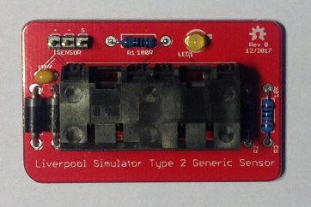

Figure 28 – Completed Generic Sensor Module PCB

### Infra-Red Sensor

As an alternative to the magneto-resistive sensors, an infra-red sensor can be built based on a commercially available modulated infra-red detector unit, marketed as an “obstacle sensor” for educational robotics projects. These sensors are available pre-assembled and are relatively inexpensive, and consequently the sensors are relatively straightforward to construct.

* The sensor emits and detects infra-red light modulated at high frequency. This makes the sensor much less sensitive than visible light or unmodulated infra-red sensors to interference from ambient lighting conditions.
* A 30mm length of 20mm black plastic conduit is used as a light shield. Once the sensor is fitted to the enclosure, lightly file or sand the exposed threads so that the shielding tube is a firm tight push fit on the end of the sensor.
* The infra-red sensor is mounted through the side of an enclosure using the plastic nuts supplied with the sensor. These should be tightened finger-tight only; do not use tools.
* It is essential to check that order of the wires in the sensor connector matches the order of the pins. The red (+5V) wire should go to the leftmost pin, the black (0V) wire to the centre pin, and the yellow (signal) wire to the rightmost pin.
* If the wires in the connector are in a different order, re-arrange them by gently prising up the plastic tabs and sliding the pin out of the housing. Slide them back in in the correct order, ensuring that the plastic tabs are gently pushed down to lock them in place.

The wiring of the infra-red sensor is illustrated in the following diagram:

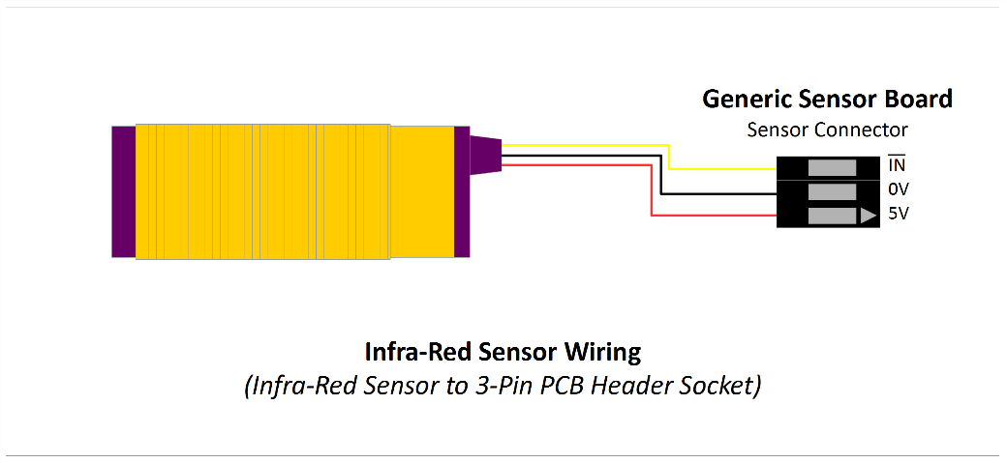

Figure 29 – Infra-Red Sensor Wiring

## Enclosures

The suggested enclosures for the Simulator Interface, Power and Sensor moduless are from the “Really Useful” series of plastic boxes, widely available from hobby and stationery shops, or direct from the manufacturer[23].

* Drilling large diameter holes with twist drills can result in bit grabbing and damage to the enclosure. Use a 20mm hole saw[24] for cable holes, this makes the process of drilling the enclosure much easier and safer.
* Support the inside surface of the enclosure with a block of scrap wood when cutting the holes and cut at a low speed.
* Clean up any rough edges or swarf with a sharp knife.
* Drill any additional holes required in the base of each sensor enclosure to suit your mounting method.
* Cables are run into the enclosures via PVC grommets, which provide some protection against dust and moisture.
* A set of suitable paper templates is available from the GitHub repository as a PDF and should be printed out full size with no scaling.

### Parts List

Table 6 – Enclosures Parts List

|  |  |  |
| --- | --- | --- |
| **Reference** | **Component** | **Notes** |
| Simulator Interface Board | Really Useful Box® 0.75 Litre | 195 x 135 x 55mm |
| Power Board | Really Useful Box® 0.75 Litre | 195 x 135 x 55mm |
| Magneto-Resistive Sensor | Really Useful Box® 0.07 Litre | 90 x 65 x 30mm, 1 per Sensor |
| Infra-Red Sensor | Really Useful Box® 0.14 Litre | 90 x 65 x 55mm, 1 per Sensor |
| Grommets | 20mm Closed Grommets | Screwfix 884VT |
| Hardware (Optional) | M3 x 12mm Nylon PCB Standoffs | eBay |

### Simulator Interface & Power Modules Enclosure

The following diagram shows the holes required in a 0.75 litre Really Useful Box for both the Simulator Interface and Power boards.

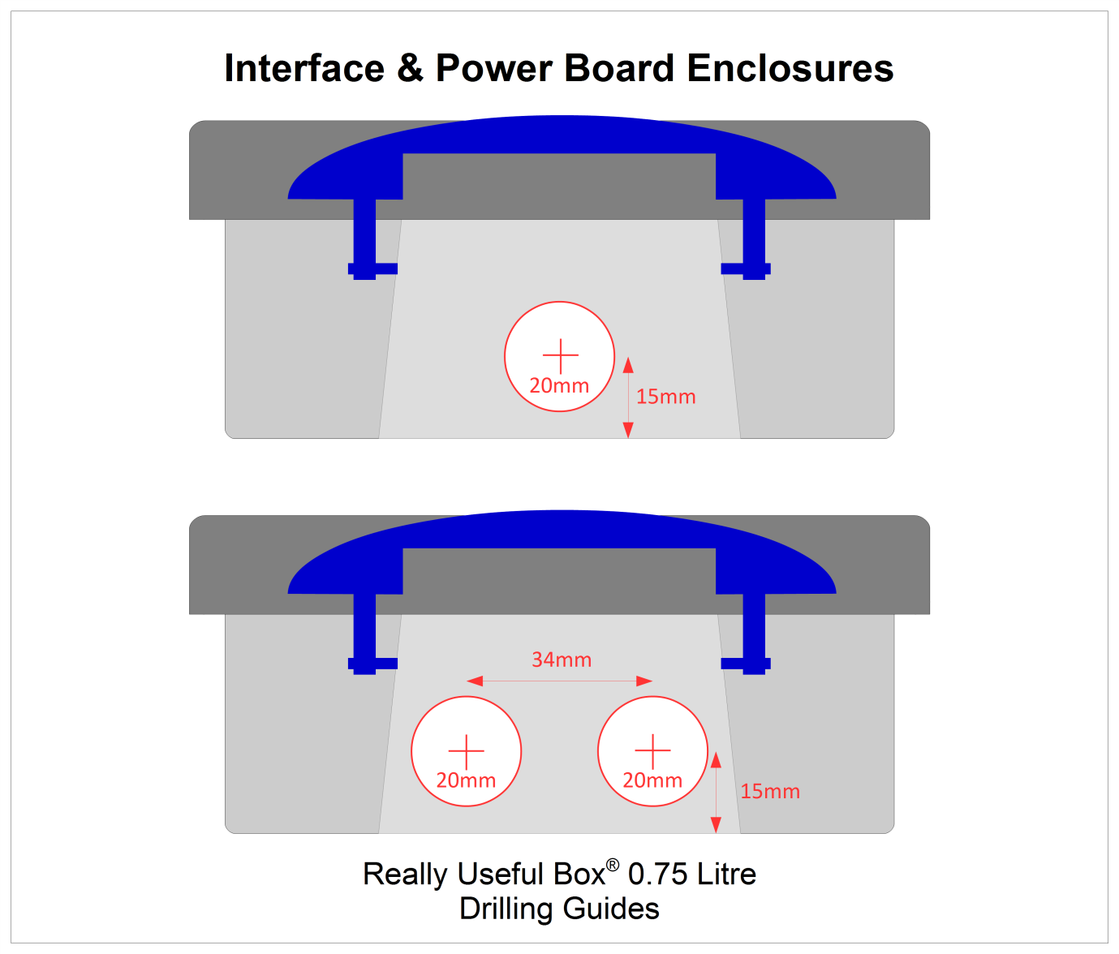

Figure 30 – Simulator Interface & Power Module Enclosure Drilling Guide

### D Sub Serial Connector Alternative Drilling

The single 20mm hole in the Power Module enclosure is sufficient for a USB-Serial adapter with a USB-A connector. If you are using an RS-232 cable with a 9-pin D Sub Connector, then a larger hole will be required. Drill two 20mm holes and cut out the area between them as shown by the dotted lines in the diagram below.

Figure – Alternative Drilling Guide for DB9 Connector

### Magneto-Resistive Sensor Module Enclosure

The following diagram shows the hole required in a 0.07 litre Really Useful Box for the Magneto-Resistive Sensor Board. The hole will catch the overhanging lip of the box slightly; this does not matter. There is no difference between right-hand and left-hand sensors.

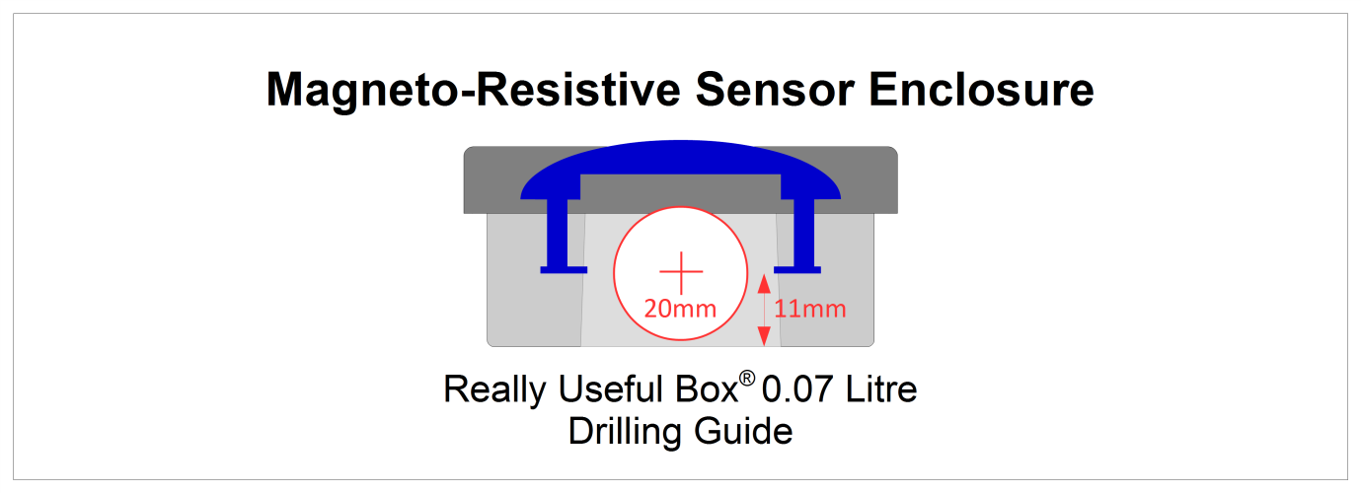

Figure 32 – Magneto-Resistive Sensor Module Enclosure Drilling Guide

### Infra-Red Sensor Module Enclosure

The following diagram shows the holes required in a 0.07 litre Really Useful Box for an infra-red sensor using the Generic Sensor Board. Cut the 18mm hole to suit either a right-hand or left-hand installation as needed.

Figure 33 – Infra-Red Sensor Module Enclosure Drilling Guide

### PCB Mounting Hardware

Optionally, the Interface and Power module PCBs may be secured to the base of the enclosure using M3 x 12mm Nylon PCB standoffs, nuts, screws and washers.

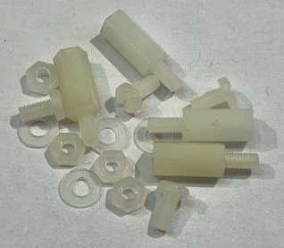

Figure – PCB Mounting Hardware

### Grommets

Cables are run into the enclosures via PVC grommets, which provide protection against dust and moisture.

* Drill one or two holes in each closed grommet. A diameter of 4.5mm should ensure a snug fit around the RJ45 cables, but this can be adjusted to suit.
* For sensors, offset the holes slightly, as shown in the twin hole example below, as this allows the cables to sit closer to the base of the enclosure.
* Using a sharp knife, make a cut as shown from the hole (link the holes if there are two), through the edge of the grommet.

The following diagram shows examples of the holes and cuts required in the grommets.

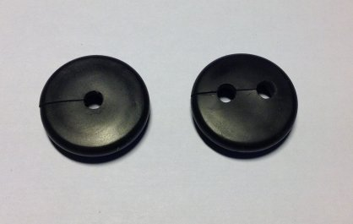

Figure 35 – Grommets Drilled & Cut

## Completed Assemblies

### Simulator Interface Module

The following photograph shows a completed Sensor Interface, with lid off and cables installed for four chains of sensors.

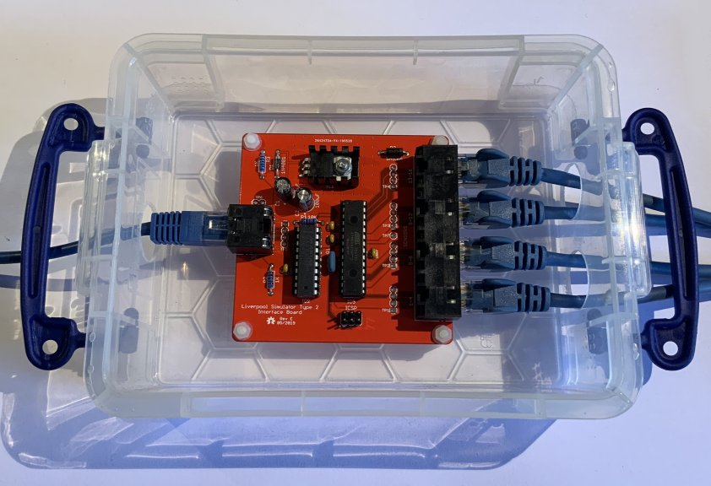

Figure 36 – Completed Sensor Interface Module

### Power Module

The following photograph shows a completed Power module, with a USB-Serial adapter also inside the enclosure.

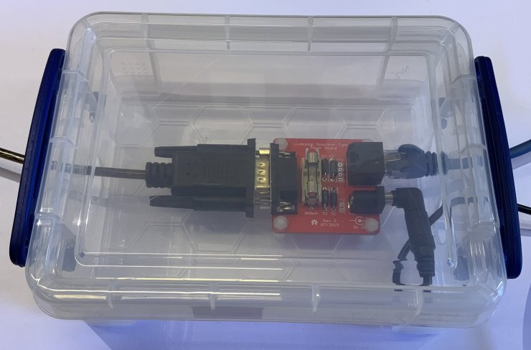

Figure 37 – Completed Power Board

### Magneto-Resistive Sensor Module

The following photograph shows a completed Magneto-Resistive Sensor module. The PCB is a snug fit in the bottom of the enclosure. If the sensor is to be mounted vertically, a cable tie around the RJ45 cables on the inside of the box will stop the board from slipping down the inside of the box.

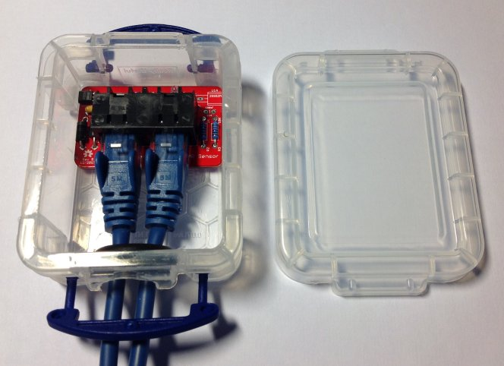

Figure 38 – Completed Magneto-Resistive Sensor Module

### Infra-Red Sensor Module

The following photograph shows a completed infra-red sensor module, using a Generic Sensor Board.

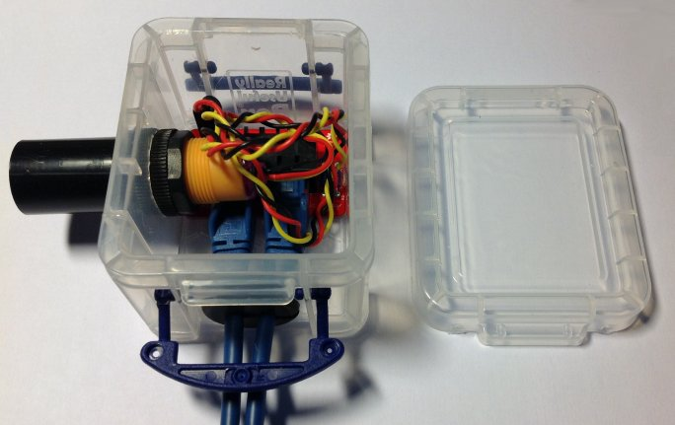

Figure 39 – Completed Infra-Red Sensor Module

# Firmware Upload

**Note: If you** **have obtained a microcontroller from the project with the firmware already uploaded to it, you can skip the whole of this section, and move on to the Installation section.**

The firmware for the Simulator Interface Board is released under the GNU General Public Licence (GPL), Version 3, and the source code and other supporting files can be downloaded from GitHub.

* <https://github.com/Simulators/simulator-type2>

The Simulator Interface firmware is held in non-volatile flash memory on the ATmega328P microcontroller. It should only be necessary to re-upload the software if the microcontroller is replaced, the flash memory has become corrupted, or the Simulator Interface firmware requires updating.

The firmware code needs to be uploaded to the microcontroller on the Simulator Interface PCB. Although the software development environment is based on the Arduino platform, the Simulator Interface does not use the Arduino bootloader, and it is not possible to upload the firmware over the interface’s RS-232 serial port. Firmware is uploaded using a hardware programmer via the ICSP header pins provided on the interface PCB.

There are three main options for the hardware programmer:

* A dedicated hardware ISP programmer such as the Microchip *Atmel ICE*[25].
* An Arduino add-on board or shield such as the *Arduino ISP*[26] *or similar shield*.
* An Arduino board (with one additional component) used as an ISP programmer.

The last of these requires no special hardware, and is the approach described in this document. There are also many tutorials online, including on the Arduino website[27].

## Hardware Programmer Options

The following photograph shows two examples of hardware programmers. On the left, an ArduinoISP device is connected directly the ICSP programming pins of a completed Simulator Interface PCB. On the right, a generic programming shield (mounted on an Arduino Uno board) can be used to upload firmware to the microcontroller before it is installed on the Simulator Interface PCB.

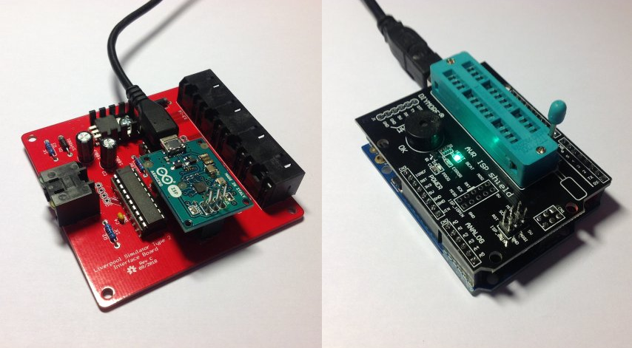

Figure 40 – Examples of Hardware Programmers

If you have access to a hardware programmer, then you can use this to upload firmware to the ATmega328P microcontroller. This guide describes an alternative method adapting an Arduino Uno board as a programmer.

## Preparing the Environment

Perform the following steps to prepare the PC software environment for compiling and uploading the Simulator Interface firmware:

* Download and install the latest version of the Arduino “Legacy IDE” package[28]. At the time of writing this was version 1.8.19.
* Start the IDE and open the program preferences by selecting *File | Preferences*.

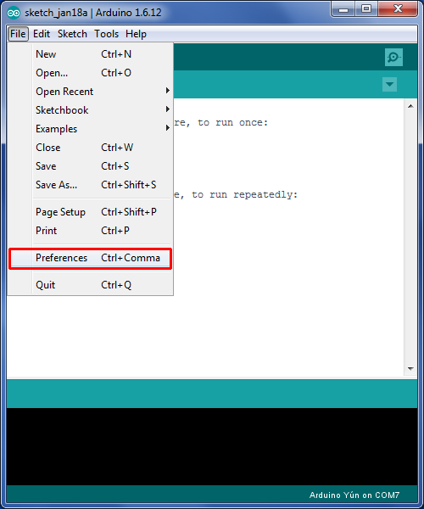

Figure 41 – Arduino IDE Preferences Menu

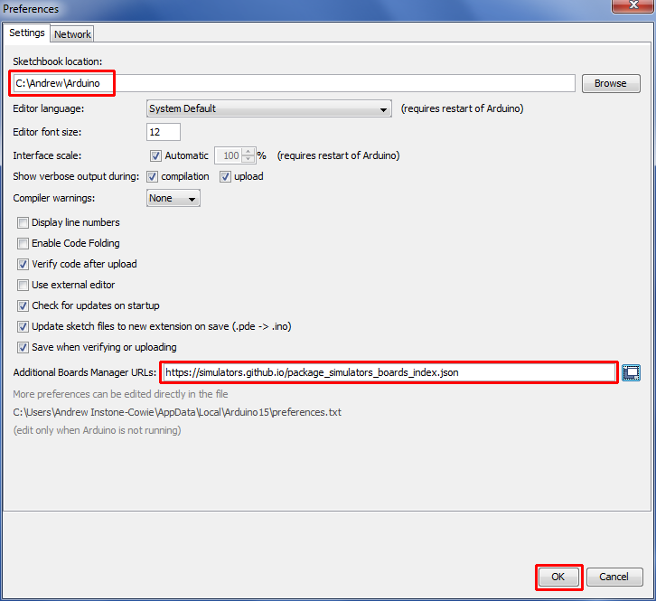

Figure 42 – Arduino IDE Sketchbook Location

* Make a note of the *Sketchbook Location* path. This is the directory into which the Simulator Interface firmware must be downloaded in a later step.
* Add the URL for the Liverpool Simulator Project boards to the *Additional Boards Manager URLs* field. The URL is:

https://simulators.github.io/package_simulators_boards_index.json

* Close the preferences dialogue by clicking *OK*.
* Open the Boards Manager by selecting *Tools | Board | Boards Manager*.

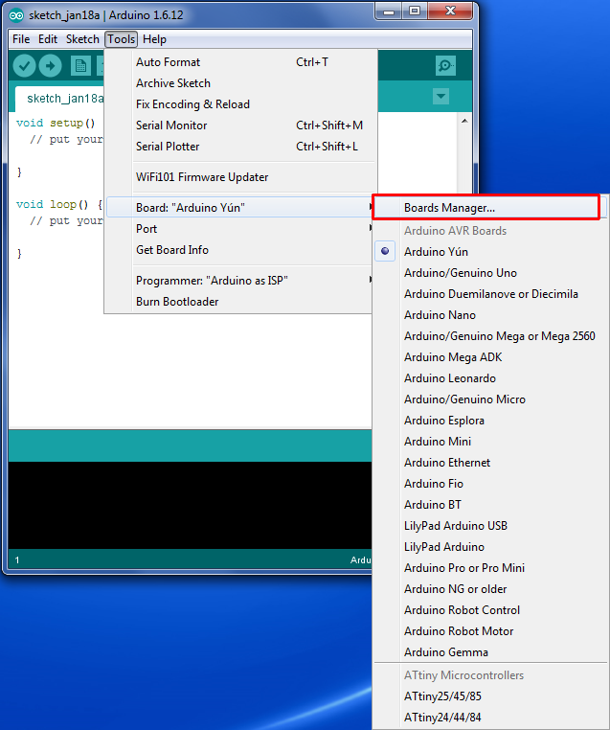

Figure 43 – Arduino IDE Boards Manager Menu

* Scroll down to the entry *Liverpool Ringing Simulator Boards*, click on the entry, and then click *Install*. The latest version of the boards package is 1.2.0. Then close the Boards Manager by clicking *OK*.

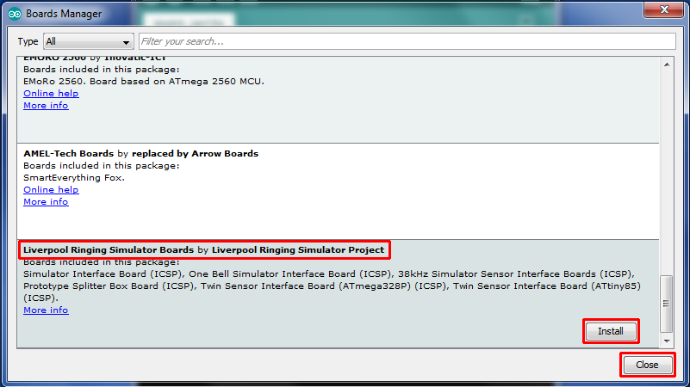

Figure 44 – Arduino IDE Board Manager

* Re-start the Arduino IDE.

The environment is now ready to set up the programmer.

## Preparing the Programmer

The programmer is an unmodified Arduino Uno board running a sketch which allows it to operate as an ISP programmer.

This requires an Arduino Uno board, and a Type A to Type B USB cable (sometimes known as a printer cable).

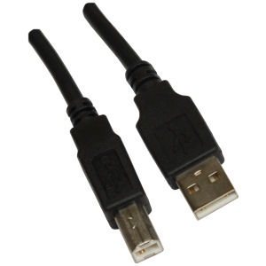

Figure 45 – Arduino USB Cable

The Arduino website has instructions on connecting the Arduino board to a computer, installing drivers and setting up the IDE.

Perform the following steps to prepare the programmer Arduino Uno board:

* Connect the *B* end of the USB cable to the Arduino Uno board to be used as the programmer. From now on this board is referred to simply as *the programmer*.
* Connect the *A* end of the USB cable to the computer.
* Follow the instructions on the Arduino site to install drivers (if necessary), and select the correct port and board type for the programmer in the IDE.
* Open the *ArduinoISP* software sketch (supplied as part of the default IDE installation) in the Arduino IDE by selecting it from the *File | Examples* menu.

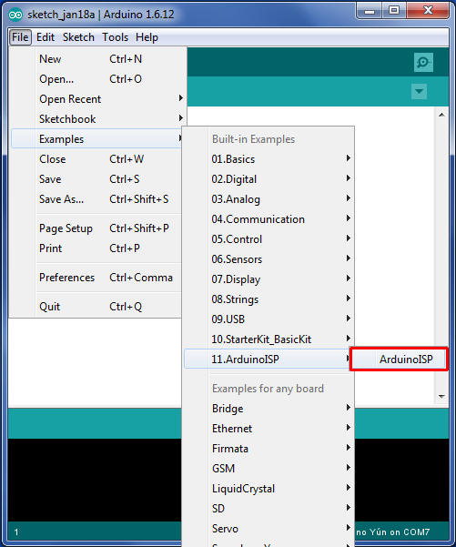

Figure 46 – Arduino IDE ISP Sketch Loading

* On the *Tools* menu, ensure the correct board type for the **programmer** is selected (*Arduino/Genuino Uno*, not *Simulator Interface Board (Type 2 Rev E+) (ICSP)*) and port. Correct these if necessary.

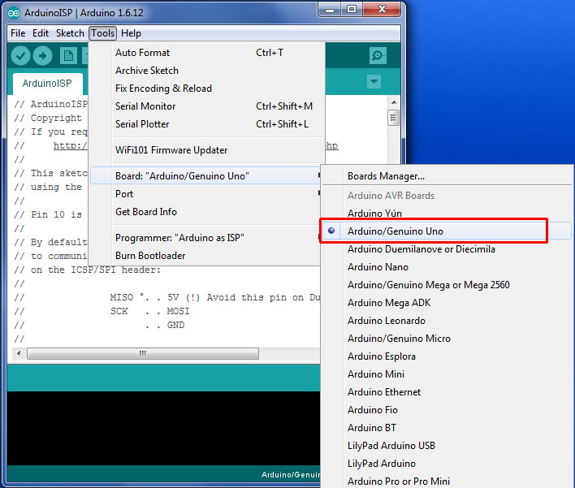

Figure 47 – Arduino Programmer Board Selection

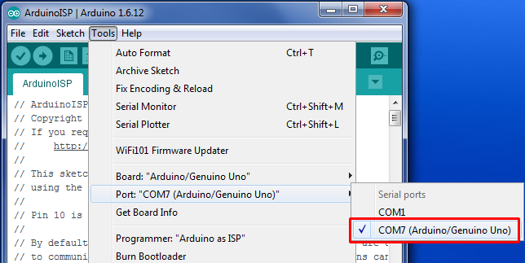

Figure 48 – Arduino Programmer Port Selection

* Click the upload (arrow) button on the IDE toolbar. The *ArduinoISP* code will be compiled and uploaded to the programmer. Verify that the upload completed successfully by looking for the *Done uploading* message.

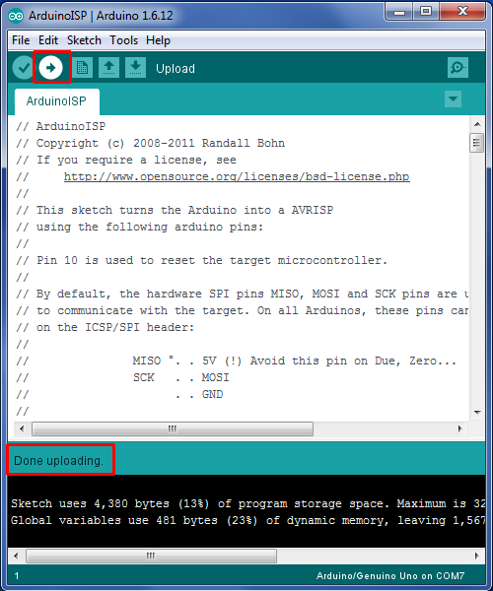

Figure 49 – Arduino IDE ISP Upload

* A failed upload will be indicated by error messages in the status area at the bottom of the IDE window.
* Disconnect the USB cable from the programmer.
* Connect a 10µF 25V electrolytic capacitor between the Reset and Ground pins of the programmer, negative side to Ground. This prevents the IDE from resetting the programmer and overwriting the *ArduinoISP* software, and allows the IDE to program the Simulator Interface.

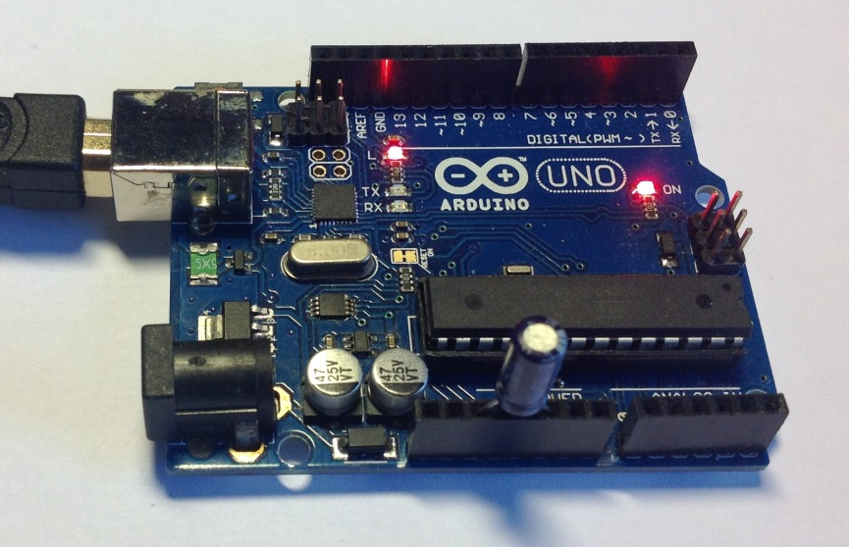

Figure 50 – Programmer with Capacitor

* Reconnect the USB cable to the programmer.

The programmer is now ready for use.

## Setting the Fuses

Perform the following steps to set the microcontroller “fuses”. The fuses and their values are explained in the ***Technical Reference Guide***.

* Disconnect the USB cable from the programmer.
* Connect the ICSP pins on the Simulator Interface to the ICSP pins on the programmer with jumper wires as shown in the following diagram.
* Pin 1 on the Simulator Interface PCB is bottom left, identified by a white dot.
* Pin 1 on the programmer is top left. Note that pin 5 on the Simulator Interface PCB is connected to pin 10 on the programmer.

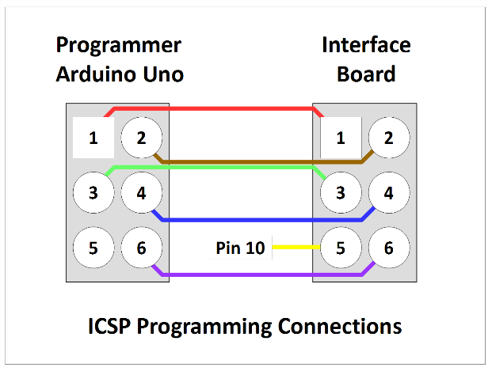

Figure 51 – Programmer Connections

* The following photograph shows the programmer connected to an interface board, including the connection to pin 10 of the programmer (yellow wire), not to the ICSP pin.

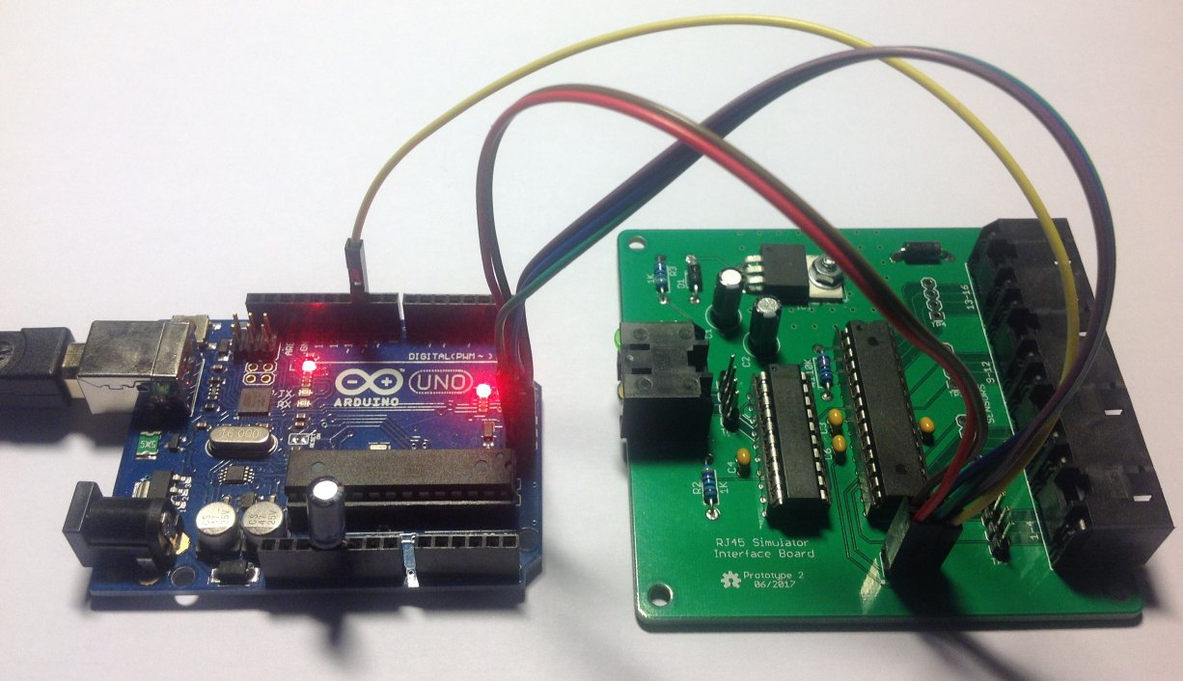

Figure 52 – Programmer Connected to Interface Board

* Reconnect the USB cable to the programmer.
* On the *Tools | Board* menu, ensure the correct target board type to be programmed has been selected, in this case *Simulator Board Interface (Type 2 Rev E+) (ICSP)*[29]*,[30]*.

Figure 53 – Arduino IDE Target Board Selection

* On the *Tools | Programmer* menu, select *Arduino as ISP* as the programmer type.

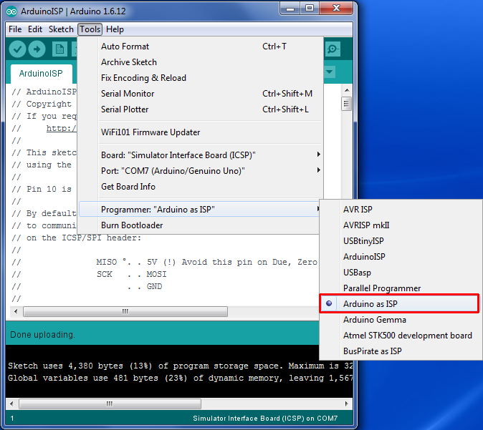

Figure 54 – Arduino IDE Programmer Selection

* On the *Tools* menu, select *Burn Bootloader*. The microcontroller fuses on the Simulator Interface Board will be set. Verify that the burn process completed successfully by looking for the *Done burning bootloader* message.

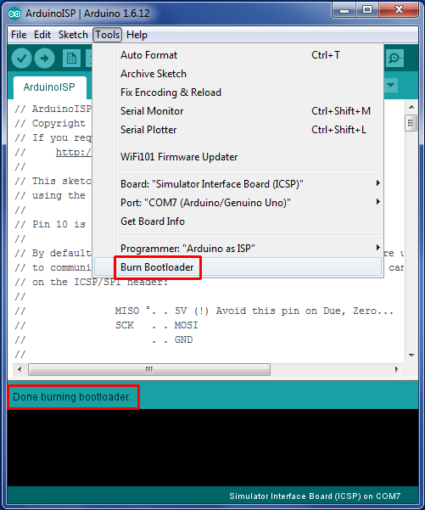

Figure 55 – Arduino IDE Burn Bootloader

* **Important note:** If a microcontroller previously used in an Arduino board is to be re-used on the Simulator Interface board, carry out the steps above to set the fuses before removing the microcontroller from the donor Arduino. Brand new ATmega328P-PU microcontrollers should be configured to use the 8MHz internal clock by default, but ones previously used on an Arduino will be configured to require an external crystal clock. Once you have set the fuses, move the microcontroller from the donor Arduino to the Simulator Interface Board.
* Note that if new firmware is being uploaded to an existing Simulator Interface Board, there should be no need to go through the steps to set the fuses every time, unless a change in fuse values is required by the new firmware.

The microcontroller is now ready for firmware upload.

## Firmware Upload

Perform the following steps to upload the Type 2 Simulator Interface firmware to the board.

* Connect the Simulator Interface Board to the programmer as described in the previous section.
* Download and install the MemoryFree[31] and VTSerial[32] libraries. For convenience these libraries are can also be found in the GitHub repository with the Simulator Interface firmware. Note that the libraries can be installed straight from the compressed zip files by selecting *Add .ZIP Library* from the *Sketch | Include Library* menu.

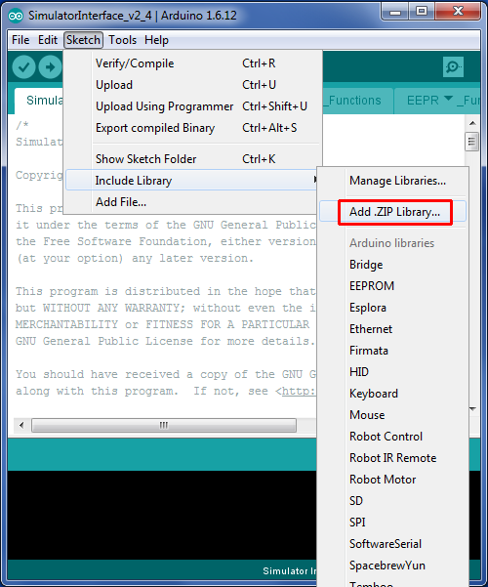

Figure 56 – Arduino IDE Add Library

* Download the Simulator Interface firmware from GitHub and unpack the files into the Arduino IDE sketchbook directory noted earlier. Note that all the firmware files must be unpacked into the directory; it is not possible to compile the firmware code from within a downloaded zip file.
* Load the firmware into the Arduino IDE by double clicking the name of the main file in Windows Explorer, e.g. *Type2Interface_v3_2.ino*.
* On the *Tools | Board* menu, as above ensure that the correct board type to be programmed has been selected, in this case *Simulator Board Interface (Type 2 Rev E+) (ICSP)*.
* On the *Tools | Programmer* menu, as above select *Arduino as ISP* as the programmer type.
* Click the upload (arrow) button on the IDE toolbar. The Simulator Interface firmware will be compiled and uploaded to the interface board. Verify that the upload completed successfully by looking for the *Done uploading* message.

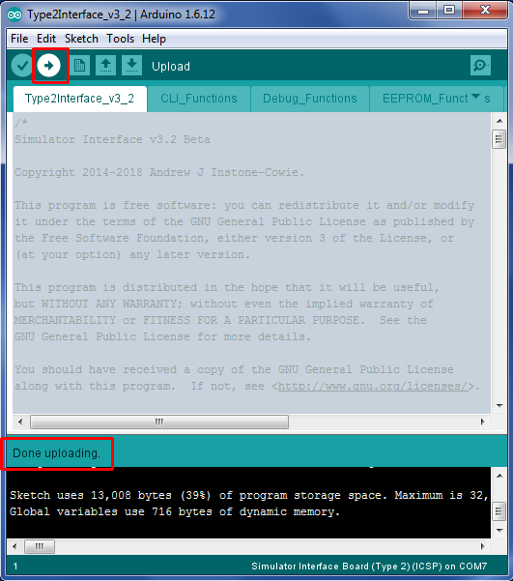

Figure 57 – Arduino IDE Firmware Upload

* A failed upload will be indicated by error messages in the status area at the bottom of the IDE window.
* When the upload has completed the Simulator Interface board will be reset, and on restarting the yellow diagnostic LED will flash according to the firmware version, for example three long and two short flashes indicates firmware version 3.2.
* Disconnect the USB cable from the programmer.
* Disconnect the programmer from the Simulator Interface Board.
* Note that when uploading new firmware to an existing Simulator Interface Board, the Sensor Head Cables and the Power/Data Cable must be disconnected from the Simulator Interface.

The Simulator Interface board now has the firmware installed and is ready for final assembly.

# Simulator Installation

## Faculty Jurisdiction Rules

If you plan to install a simulator in a tower which falls under the Church of England *Faculty Jurisdiction Rules*, then from 1st April 2020 you will need the Archdeacon’s formal approval for the installation. Installation of a simulator comes under *List B[33]*, which covers minor works which can be undertaken with the Archdeacon’s approval[34], and does not require the granting of a full faculty.

The schedule of rules[35] (as amended in 2022) runs to 73 pages, but the item covering the installation of a simulator can be found under item B2(6) of List B, “*installation of an electric silent ringing device for the training of ringers*”.

### List B Application

The application process is relatively straightforward, and is all handled online via the *Church of England Online Faculty System*, which can be found here:

<https://facultyonline.churchofengland.org/home>

The application would usually be made on behalf of the church by an officer of the PCC. Full guidance is available on the *Online Faculty System* website[36].

The Liverpool Ringing Simulator Project documentation, or extracts from it, may be used to support your application, provided its source is acknowledged: all documentation is released under the Creative Commons Attribution-ShareAlike 4.0 International License (CC BY-SA) which permits you to re-use it for any purpose.

### Conditions

There are four standard conditions attached to item B2(6). These are listed and their implications discussed in the following table:

|  |  |
| --- | --- |
| **Condition** | **Implications** |
| *Any work to an electrical installation or electrical equipment is carried out by a person whose work is subject to an accredited certification scheme (as defined in rule 3.1(6)).* | * This condition is likely to apply only if you require additional socket outlets installing to power the simulator, PC, etc * This condition essentially means that the church must engage a qualified electrician to do that work. |
| *The device is installed in a location not normally visible to the public.* | * Bell chambers and upstairs ringing rooms would not normally be considered visible to the public. * If the tower is, for example, a ground floor ring open to the body of the church, then you may need to arrange to store the ringing room equipment away when not in use, but that is probably advisable anyway for security. |
| *No alteration is made to the fittings of the bells other than the installation of electric contacts and wires.* | * No alteration to the fittings of a bell should be required to install a simulator or sensor. * The example installations depicted in this guide show how sensor mountings can be devised which require no permanent fixings. * No modern simulator uses “electric contacts”, and the terminology in this condition is antiquated, but could be construed to apply to optical or magnetic sensors. |
| *The device does not adversely affect the church’s protection against lightning.* | * The Liverpool Ringing Simulator design includes Transient Voltage Suppression devices on all signal and data lines. These are intended to protect the simulator itself and any downstream components from transients induced by, for example, nearby lightning strikes. For more information, please refer to the ***Technical Reference Guide***. * Unless there are very unusual installation requirements, the presence of a simulator should present no additional hazard. |

The best advice is, if in any doubt, discuss the installation with the Archdeacon before making an application.

## Simulator Interface Module

The Simulator Interface module is located in the belfry, in a location convenient for routing cables to the sensors and the power/data cable down to the ringing room. Try to pick a sheltered location where the interface will be out of the way.

The following picture shows the Simulator Interface module at Lois Weedon in the belfry. Note the two cables for chains of sensors.

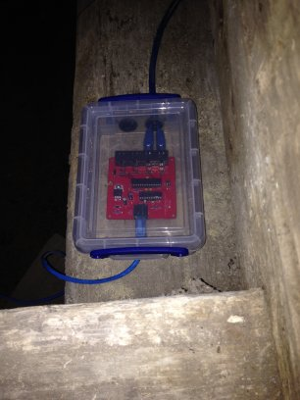

Figure 58 – Installed Simulator Interface

The Simulator Power/Data Cable is routed from the Simulator Interface down to the Power module.

* The cable should be secured to prevent the weight of the cable pulling on the connectors.
* The minimum diameter of any holes along the cable route is approximately 12mm, to allow the RJ45 connector to pass through (unless you are making your own cables in-situ).

## Power Module

The Power module enclosure is located near the Simulator PC. There is enough room in the enclosure to house a USB-Serial adapter, if one is required.

### Power Supply

A plug-in power supply is required to supply power to the Simulator Interface via the Power Board.

* A regulated DC power supply rated at least 1 Amp with multiple selectable output voltages is recommended, for example Farnell 2802689 or similar.
* The output connector required is 2.1mm x 5.5mm, centre pin positive.
* The output voltage of the power supply should be adjusted so that the supply voltage at the input to the Simulator Interface (measured at TP6) is at least 7.5 volts, with all sensors connected.
* The supply voltage may be higher than that required to maintain 7.5 volts at the Interface, but this will result in increased heat dissipation from the voltage regulator.
* As a guideline, a supply voltage of 9V is generally sufficient to maintain the required voltage, with a 25m Power/Data cable.

## Sensor Module Mounting

The magneto-resistive sensors are attached to the bell frame, such that the centre of the magnet is positioned directly opposite the axis of the sensor IC when the bell is down, with a clearance of not more than approximately 30-40mm. The means of mounting the sensors will need to be adapted to suit local conditions, but some examples are shows below.

Sensors can be mounted vertically or horizontally.

The following photographs show magneto-resistive sensors installed at Lois Weedon, using locally made timber brackets clamped around a wooden bell frame with threaded rod. The magnet mounts are also visible.

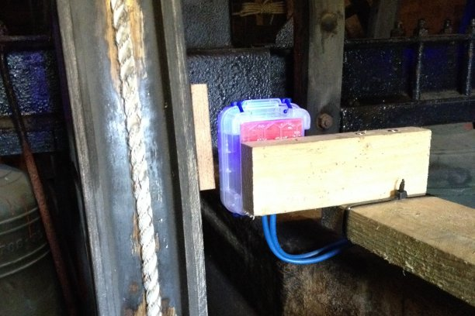

Figure 59 – Installed Sensor (Lois Weedon 4th)

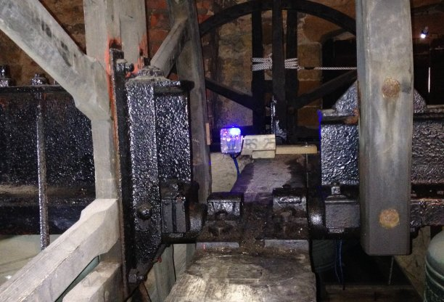

Figure 60 – Installed Sensor (Lois Weedon 6th)

The following photograph shows a (Type 1) optical sensor installed at Chirk, on a timber support secured to the metal bell frame with cable ties. The reflectors on the wheels can also be seen.

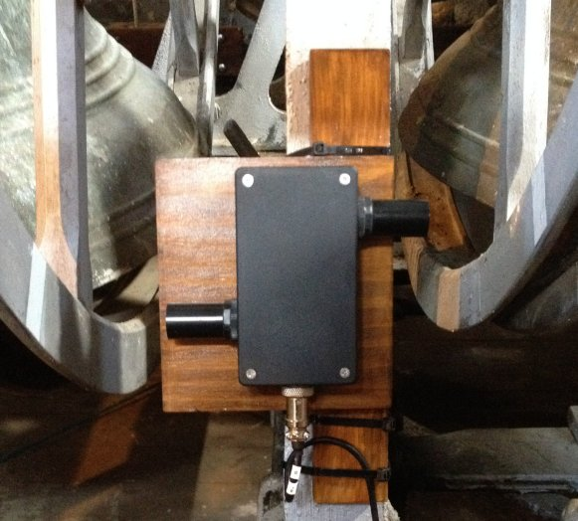

Figure 61 – Installed Sensor (Chirk, Type 1)

## Magnet Mounting

The magneto-resistive sensor is triggered by a small rare-earth magnet mounted on the shroud of the wheel, such that the magnet is opposite the centre of the Sensor Head (i.e., co-axial with the 2SS52M sensor IC) when the bell is at the bottom of its swing.

The magnet used is a N52 grade rare earth magnet, 20mm diameter x 10mm thick. The following mounting is suggested for a permanent installation: The trigger magnet is mounted in a “flange” cut from 12mm WBP plywood, which is then fixed to the shroud of the wheel using stainless steel screws or double-sided tape.

The dimensions of the mounting flange are show in the following diagram:

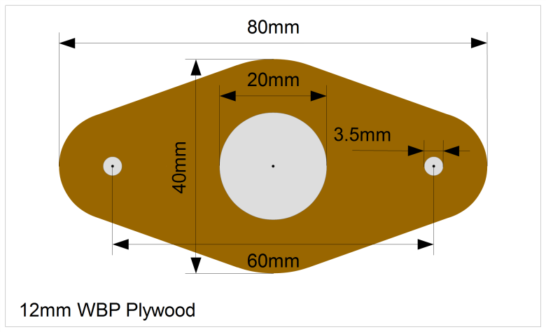

Figure 62 – Magnet Mounting Dimensions

The magnet mountings are constructed as follows:

* The shape of the mounting is marked out on a piece of WBP plywood, 12mm thick. A paper template may be printed out and stuck temporarily to the wood with glue or double-sided tape. A suitable template is available from the GitHub repository as a PDF and should be printed out full size with no scaling.
* The centre hole for the magnet is drilled out with a 20mm spade bit. This should be used in a bench drill press, if available, so that the hole is reasonably accurately cut, and the magnet will be a close fit.
* If the mounting is to be fixed to the wheel with screws, the screw holes are also drilled. It is easier to drill all the holes before cutting the mount to size.
* The mounting is then cut and sanded to shape, and the remains of the template removed. Do not sand the inside of the central hole.

These steps are illustrated in the following series of pictures.

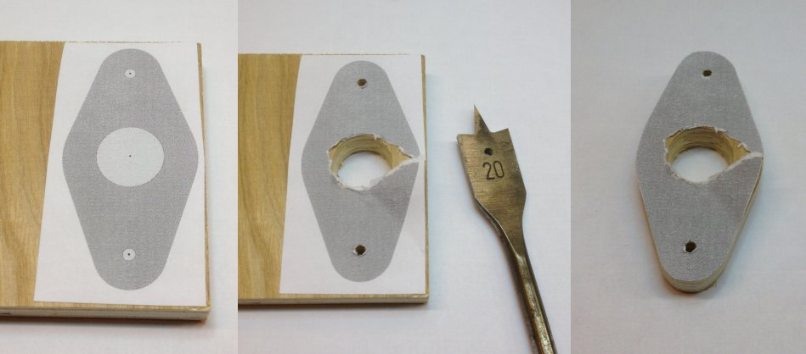

Figure 63 – Magnet Mounting Construction

The magnet is pushed into the central hole, and secured with a small amount of epoxy adhesive (e.g. Araldite). The face of the magnet should be flush with the outer face of the mount, and note that for the Honeywell sensor the polarity of the magnet is not important.

The following picture shows a completed magnet mounting, ready for painting.

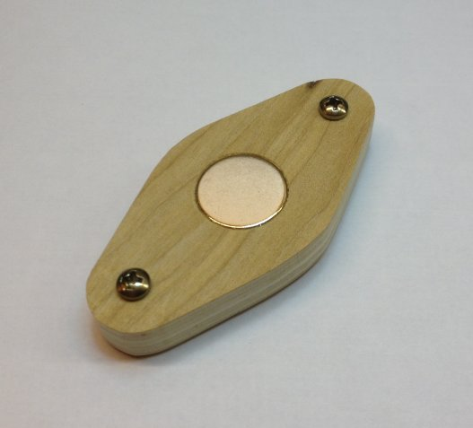

Figure 64 – Completed Magnet Mounting

Care must be taken when handling the rare earth magnets, because they are both powerful and brittle, and can strike a magnetic object with enough force to shatter the magnet. They are also susceptible to corrosion, so must be painted or coated with a thin layer of epoxy.

Once painted the mounting can be fixed the wheel with pan head stainless steel self-tapping screws 3.5mm (No. 6) in diameter and 20mm – 25mm long; the screws should not protrude through the shroud of the wheel. Alternatively, the mount can be secured with double-sided tape, provided the surface of the wheel is sound and free from dust.

## Infra-Red Sensors

The sensor is attached to the bell frame in a similar way to a magneto-resistive sensor, such that the sensor masking tube is perpendicular to the face of the shroud of the wheel.

### Reflector

The sensor requires a reflector mounted on the shroud of the wheel, such that the reflector is opposite the Sensor Head when the bell is at the bottom of its swing.

The reflector is made from a short length of white reflective automotive styling tape, 25mm wide (which may be obtained from a car spares shop), positioned directly opposite the sensor tube when the bell is down.

### Calibration

As supplied, most of the infra-red detector sensor modules have been found to draw approximately 55 – 60mA, much more than the specified 25mA, and were excessively sensitive. The small calibration screw on the back end of the module may be used to reduce both the current consumption and sensitivity of the detector.

A useful starting point for sensitivity adjustment has been found to be to reduce the sensitivity of the sensor such that it does not trigger when placed perpendicular to a piece of grey card at a distance of 90mm from the end of the detector. The multi-turn adjustment screw is turned anti-clockwise until the indicator LED on the back of the module just goes out. This gives an effective maximum trigger distance with the reflective tape of about 300mm. This also reduces the supply current.

Fine adjustment of the sensor should then be carried out in the belfry for optimum sensitivity.

## Cabling

### Power/Data Cable

The Power/Data Cable runs between the Power module and the Simulator Interface module.

* The cable is a standard straight-through (not crossover) Cat5e or Cat6 Ethernet network cable, with RJ45 connectors. These are available ready-made, for example from Farnell or CPC.
* The maximum length of cable tested is 25m, although longer cables may be feasible.
* Examples of a 25m cable are Farnell part number 2575533 or CPC CS24970.

### Sensor Cables

The sensor modules are also cabled back to the Simulator Interface module using standard Cat5e or Cat6 network cables.

* The cables are a standard straight-through (not crossover) Cat5e or Cat6 Ethernet network cable, with RJ45 connectors. These are available ready-made, for example from Farnell or CPC.
* The maximum tested length of a chain of four sensors is 20m, made up of 4 x 5m cables, although longer cables may be feasible.
* Examples of a 5m cable are Farnell part number 1734948 or CPC CS17415.

Sensors are wired in a “daisy chain” fashion, with each chain consisting of a maximum of four sensors. The wiring of one chain is illustrated in the following diagram.

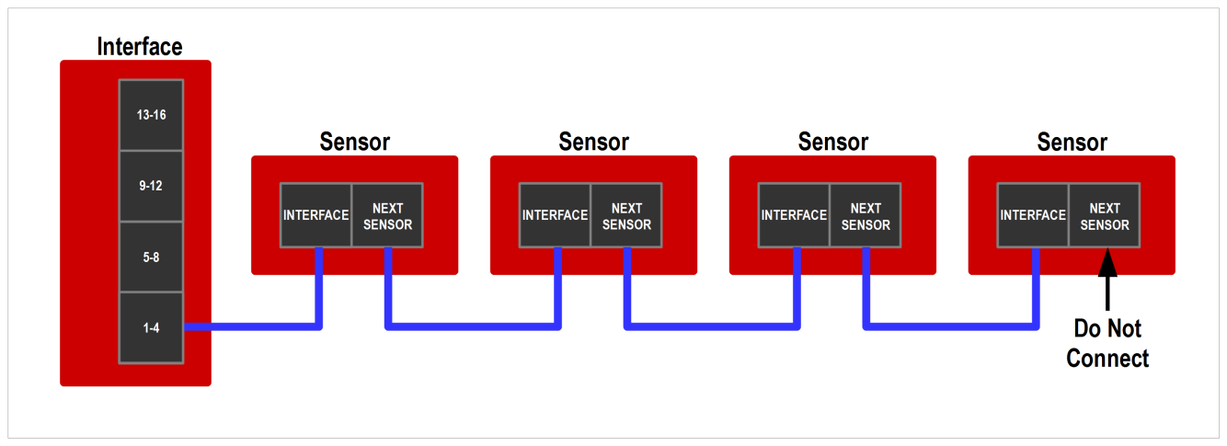

Figure 65 – Sensor Daisy Chain

It is important to understand that there is no requirement to connect any particular sensor to any specific bell, and no requirement that chains should consist of any particular number of sensors.

* The cabling should be arranged to suit the layout and constraints of the belfry.
* The relationship between Simulator Interface channels and bells will be managed in the interface firmware. This is explained in a worked example later in this guide.
* There are obvious constraints for higher numbers of bells: A ring of 12 will require at least three sensors on each chain, and a ring of 16 will require all four chains with four sensors each.

### Computer Connection

The simulator Power Board is connected to the Simulator PC in the ringing room with a serial cable. The type of cable required depends on the kind of serial port built into the PC.

#### 9-Pin Serial Connector

The Simulator PC may be fitted with a 9-pin RS-232 serial or “COM” port, as illustrated in the following diagram:

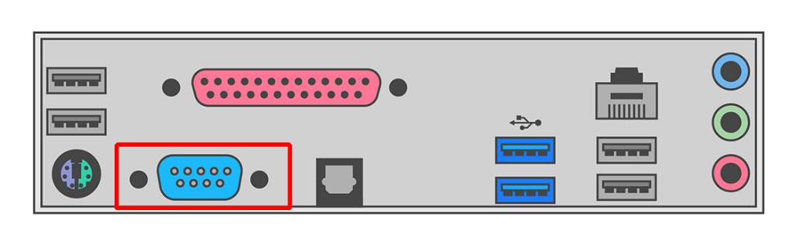

Figure 66 – 9-Pin Serial Port

This type of serial port is common on older computers, but not often found on newer models.

If the Simulator PC has a 9-pin serial port, use a 9-pin Female to 9-pin Male straight-through[37] serial cable to connect the computer to the simulator interface. Examples of suitable cables are Farnell part 2444240 (1.8m), CPC part CS24423 (1m), or CPC part CS24424 (2m).

A typical cable, with the connectors required, is illustrated in the following photograph:

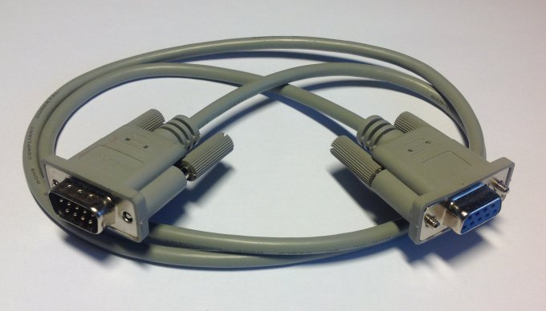

Figure 67 – 9-Pin Serial Cable

If your computer has both a 9-pin serial port and USB ports, use the 9-pin serial port.

#### USB Connector

More modern computers are likely to be fitted only with USB ports, as illustrated in the following diagram:

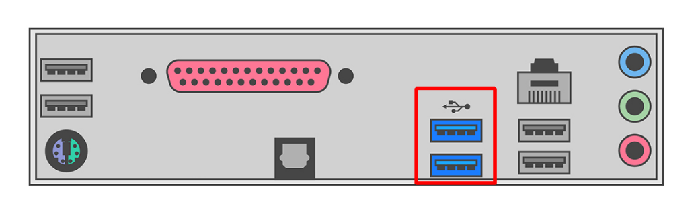

Figure 68 – PC USB Ports

In this case, use a USB-Serial adapter to connect the simulator Power Board to a spare USB port on the Simulator PC. If necessary, a straight through serial cable as above can be used as an extension.

An example of a typical USB-Serial adapter is illustrated in the following photograph[38]. Note that an extension cable may be required if (as in this case) the adapter does not have securing screws.

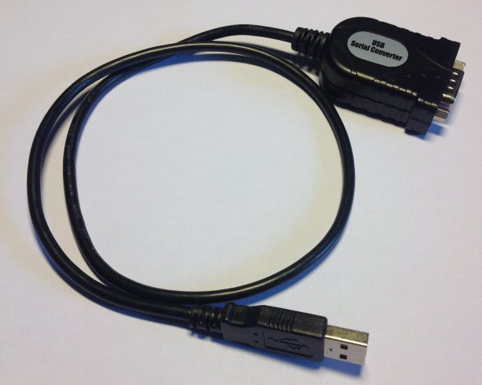

Figure 69 – USB to Serial Adapter

Install the drivers supplied with the adapter and identify the COM port number allocated (you will need to know this later to configure your Simulator Software Package).

There is more information on USB-Serial adapters in the ***Technical Reference Guide***.

# Interface Module Setup

The Type 2 Liverpool Simulator Interface module is highly configurable, but most of the default settings should be fine for most installations. There is detailed information about all the configuration options in the ***Technical Reference Guide***.

There are a couple of configuration options which you should set before using the simulator: disabling unused sensor channels, and re-mapping sensors to bells. Configuration of the Simulator Interface should only need to be done once. All settings are retained in non-volatile EEPROM when the interface is powered off.

**Note**: When multiple PCs are connected, only one PC can be used to configure the Simulator Interface using a terminal emulator. Refer to the Multi-PC Guide for more information.

## Connecting to the Interface Module

* On the Simulator PC, ensure that a Simulator Software Package (e.g. Abel) is not running. Close the Simulator Software Package down if it is running.
* Download and install a serial terminal emulator package[39]. This manual assumes the use of the Open Source PuTTY terminal emulator.
* Start the PuTTY terminal emulator by double-clicking the PuTTY icon on the desktop.



* Configure a Serial connection using the COM port number of the serial port (e.g. COM1), running at 2400 bps, and then click Open. You should not need to change any other settings in PuTTY.

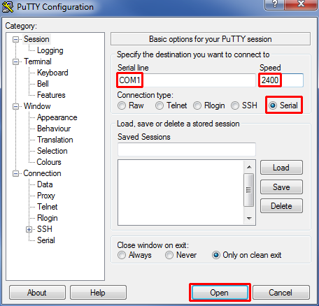

Figure 70 – PuTTY Configuration Dialogue

Click on the PuTTY terminal window, then type “?” (question mark). There is no need to press Enter. After a short pause the Simulator Interface will respond by displaying its current settings, which may not be identical to these examples[40].

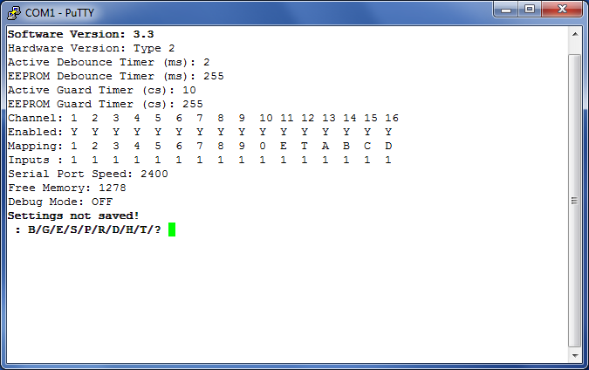

Figure 71 – Display Interface Settings

## Worked Example

The following worked example shows how to disable unused sensor channels, and re-map channels when setting up the Simulator Interface. You should adapt the instructions in the worked example to suit your installation.

### Sensor Channels

Before configuring the interface, it is important to understand the difference between interface sensor channels numbers, and numbers of the bells. The channel numbers are fixed as shown in the diagram below: Channel 1 is always the first sensor on the first chain, channel 2 is always the second sensor on the first chain, and so on up to channel 16.

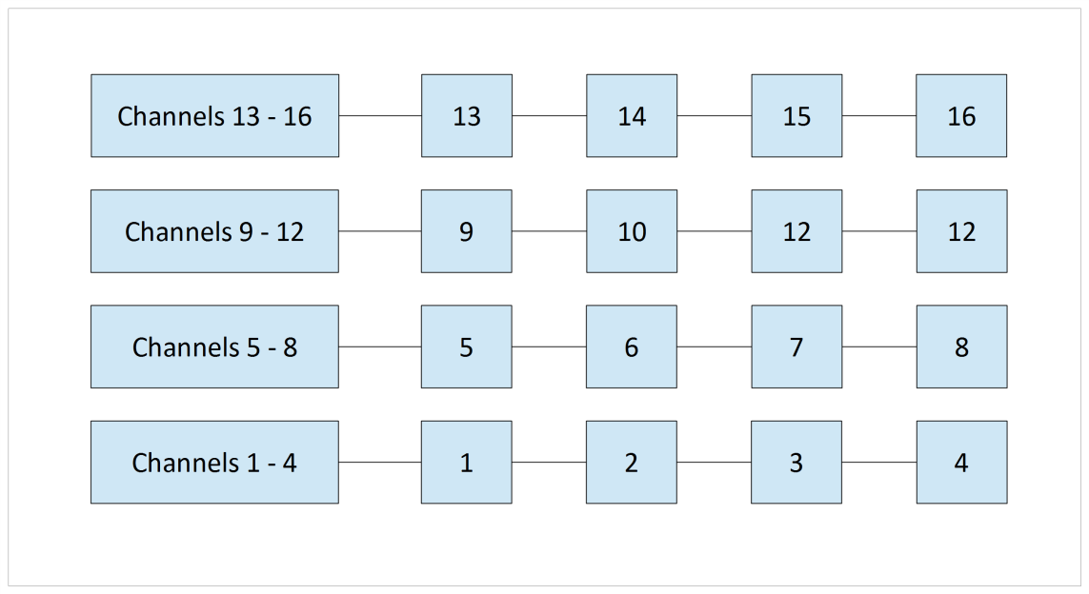

Figure 72 – Interface Channel Numbers

To re-iterate the guidance in the previous section, there is no requirement to connect any particular sensor to any specific bell, and no requirement that chains should consist of any particular number of sensors. The sensor cabling should be arranged to suit the layout and constraints of the belfry.

### Example Installation

The diagram below shows the sensor cabling for a mythical ring of six. The cables between the sensors and the interface have been routed as shown, to avoid the clock wires, chiming hammers, rope chutes and all the other things which clutter up the belfry. This example is deliberately convoluted to show how the interface settings can be configured.

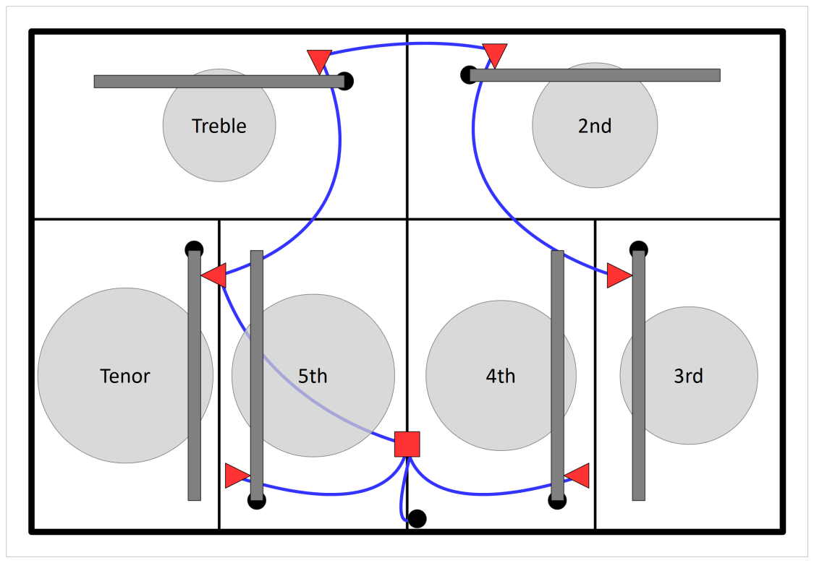

Figure 73 – Example Sensor Cabling

As a result, the sensors on the bells are connected to the following channels. Channels 6, 7, 8, and 10 to 16 are not used.

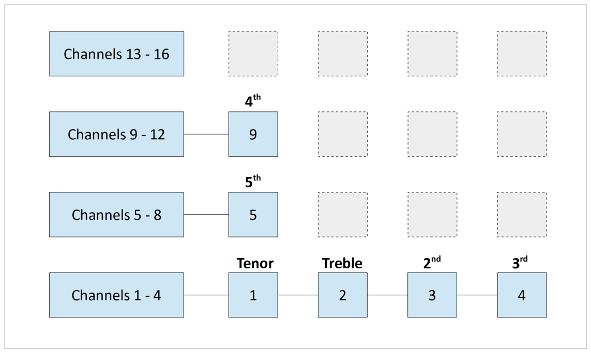

Figure 74 – Example Channel Connections

These unused channels will be disabled on the simulator interface. There is no point scanning these channels for sensor signals, as there are no sensors connected to them.

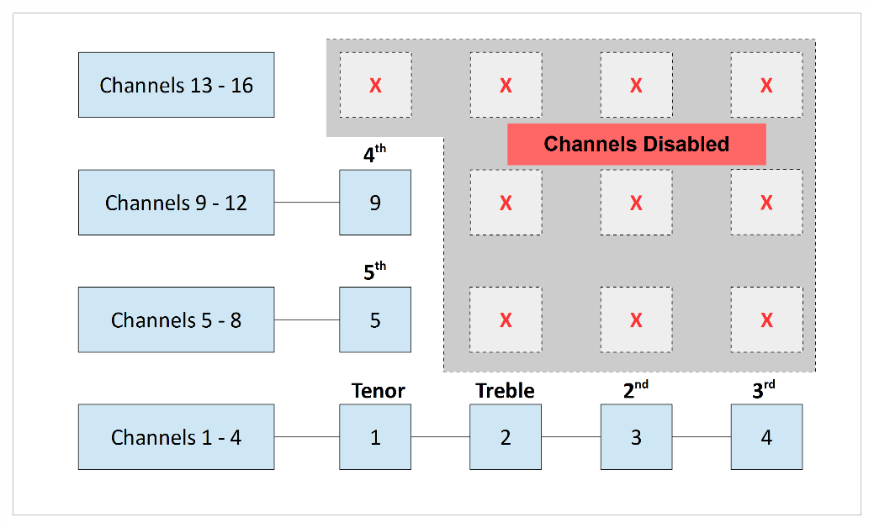

Figure 75 – Disabled Channels

### Default Settings

Open a terminal session to the interface using PuTTY, as described above.

* The “?” command shows the default settings:



Figure 76 – Default Settings

### Disable Unused Channels

* To disable (or enable) channels, use the “E” command. There is no need to press Enter after typing the “E”.
* Enter the number of each channel to be disabled, pressing Enter after each one. In the example below, channels 6, 7, 8, and 10 to 16 are disabled.
* When you have finished, enter a zero (or just press Enter).
* The interface software will not allow you to disable all the sensors.
* These settings are not saved yet and will revert to the defaults if the interface power is turned off. The settings will be saved later.

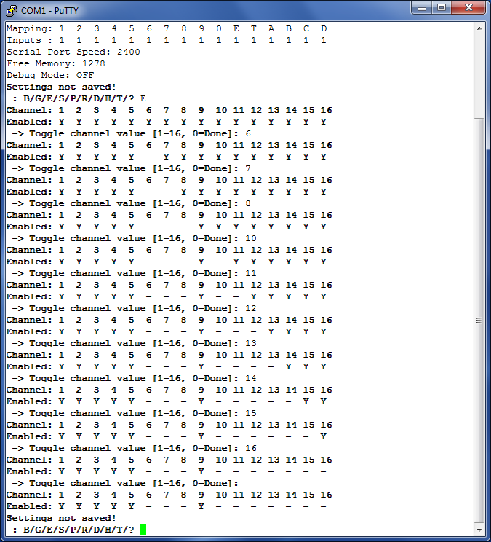

Figure 77 – Disabling Channels Example

### Re-Map Channels to Bells

Although the mapping between the channel/sensor numbers and the real bell numbers can be reconfigured in most Simulator Software Packages, it is less confusing if this is set in the simulator interface.

In the example installation above, the interface channels are mapped to the real bells as follows:

Table 7 – Example Channel Mapping

|  |  |
| --- | --- |
| **Channel** | **Bell** |
| 1 | 6 |
| 2 | 1 |
| 3 | 2 |
| 4 | 3 |
| 5 | 5 |
| 9 | 4 |

* To re-map a channel to a real bell number, use the “R” command. There is no need to press Enter after typing the “R”.
* Enter the number of each channel to be remapped, and press Enter.
* Then enter the number (or letter) of bell to which that sensor is attached, and press Enter. The numbers and letters follow the usual ringing conventions, as shown in the table below:

Table 8 – Bell Numbers & Letters

|  |  |
| --- | --- |
| **Bells** | **Bell Numbers/Letters** |
| 1 to 9 | 1 – 9 |
| 10 | 0 |
| 11 | E |
| 12 | T |
| 13 to 16 | A – D |
| Switches | W – Z |

* Letters W, X, Y and Z are used in Abel switch configurations, and are not normally used. More information on switches can be found in the ***Technical Reference Guide***.
* Repeat for all the other channels to be re-mapped. In the example below, channels 5 is already allocated to the 5th, so no re-mapping is needed.
* When you have finished, enter a zero (or just press Enter).
* The interface software will warn you if duplicate mappings are defined, but will not prevent you from saving such a configuration[41].
* These settings are not saved yet and will revert to the defaults if the interface power is turned off. The settings will be saved later.

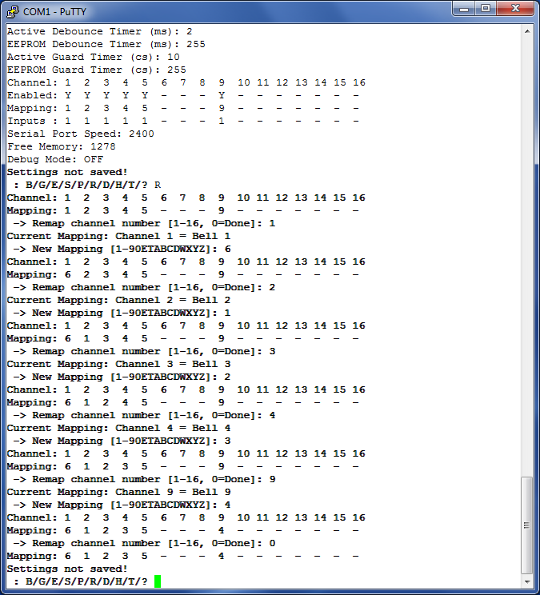

Figure 78 – Channel Re-Mapping Example

### Save Settings

* Review your settings with the “?”command.

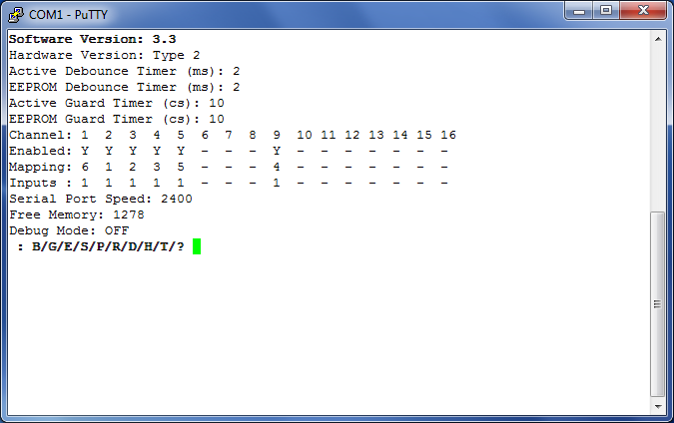

Figure 79 – Example Channel Connections

* Finally, save the settings using the “S” command, and then close the terminal window.

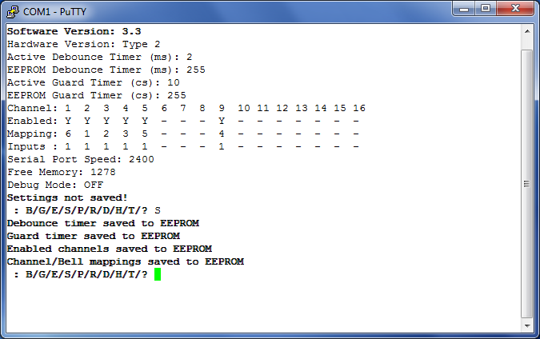

Figure 80 – Saving Interface Settings

# Next Steps

You are now ready to move on to configure your chosen Simulator Software Package to work with the simulator. Instructions for configuring the main Simulator Software Packages can be found in the following guides:

* ***Configuring Abel Guide***
* ***Configuring Beltower Guide***
* ***Configuring Virtual Belfry Guide***

If your Simulator Software Package is not listed above, please refer to the vendor’s instructions on configuring their software to work with external sensors.

If you want to use multiple PCs concurrently, see the ***Multi-PC Guide*** for more information.

# Licensing & Disclaimers

## Documentation

All original manuals and other documentation (including PCB layout CAD files and schematics) released as part of the Liverpool Ringing Simulator project[42] are released under the Creative Commons Attribution-ShareAlike 4.0 International License (CC BY-SA),[43] which includes the following disclaimers:

*Unless otherwise separately undertaken by the Licensor, to the extent possible, the Licensor offers the Licensed Material as-is and as-available, and makes no representations or warranties of any kind concerning the Licensed Material, whether express, implied, statutory, or other. This includes, without limitation, warranties of title, merchantability, fitness for a particular purpose, non-infringement, absence of latent or other defects, accuracy, or the presence or absence of errors, whether or not known or discoverable. Where disclaimers of warranties are not allowed in full or in part, this disclaimer may not apply to You.*

*To the extent possible, in no event will the Licensor be liable to You on any legal theory (including, without limitation, negligence) or otherwise for any direct, special, indirect, incidental, consequential, punitive, exemplary, or other losses, costs, expenses, or damages arising out of this Public License or use of the Licensed Material, even if the Licensor has been advised of the possibility of such losses, costs, expenses, or damages. Where a limitation of liability is not allowed in full or in part, this limitation may not apply to You.*

## Software

All original software released as part of the Liverpool Ringing Simulator project is released under the GNU General Public Licence (GPL), Version 3[44], and carries the following disclaimers:

*This program is free software: you can redistribute it and/or modify it under the terms of the GNU General Public License as published by the Free Software Foundation, either version 3 of the License, or (at your option) any later version.*

*This program is distributed in the hope that it will be useful, but WITHOUT ANY WARRANTY; without even the implied warranty of MERCHANTABILITY or FITNESS FOR A PARTICULAR PURPOSE. See the GNU General Public License for more details.*

# Acknowledgements

The Liverpool Ringing Simulator project relies extensively on work already undertaken by others, notably David Bagley (developer of the Bagley MBI), Chris Hughes and Simon Feather (developers of the Abel simulator software package), Derek Ballard (developer of the Beltower simulator software package), Doug Nichols (developer of the Virtual Belfry simulator software package), and others. Their invaluable contributions are hereby acknowledged. Sources used are referenced in the footnotes throughout.

Thanks are also owed to the Ringing Masters and ringers of the following towers for their willingness to be the crash test dummies of simulator design and testing.

* Liverpool Cathedral
* St George’s, Isle of Man
* St Mary, Chirk, Wrexham
* St John, Higham, Kent
* St Margaret, Crick, Northamptonshire
* St Mary & St Peter, Lois Weedon, Northamptonshire

Really Useful Box ® is a registered trademark of Really Useful Products Ltd.

1. <https://creativecommons.org/licenses/by-sa/4.0/>
2. <https://www.abelsim.co.uk>
3. <https://www.beltower.co.uk>
4. <https://www.belfryware.com>
5. Printed Circuit Board
6. This price is for HASL finish leaded solder PCBs, other finishes have higher costs.
7. Panelized boards pricing is slightly more complex, but handled automatically by the fabrication service.
8. A single set of Gerber files is provided, which should be suitable for all the manufacturers mentioned.
9. If you require lead-free boards for commercial reasons, specify Lead-Free HASL or ENIG. There is an additional cost for these finishes.
10. Permalinks to OSH Park are no longer provided in this document. Always upload the latest Gerber files from GitHub when ordering.
11. In-Circuit Serial Programming
12. Multi-Layer Ceramic Capacitor
13. PCB Revision E onwards
14. Not required if you have obtained a microcontroller from the project with the firmware already loaded.
15. From PCB Revision C onwards only. Do not use this method with older boards, the voltage regulator alignment was adjusted in Revision C for this purpose.
16. <http://www.gremlyn.plus.com/ahme/mag_sen.html>
17. <https://sps.honeywell.com/us/en/products/advanced-sensing-technologies/industrial-sensing/industrial-sensors/magnetic-sensors/omnipolar-position-sensor-ics/2ss52m-series>
18. The Amphenol RJHSE-5080-02 connector originally specified is no longer stocked by Farnell. The alternative AMP TE Connectivity part 5406526-1 is a direct replacement.
19. See ***Technical Reference Guide*** for more information.
20. The Amphenol RJHSE-5080-02 connector originally specified is no longer stocked by Farnell. The alternative AMP TE Connectivity part 5406526-1 is a direct replacement.
21. <https://hobbycomponents.com/sensors/213-ir-infrared-obstacle-avoidance-sensor-e18-d80nk>
22. <https://shop.4tronix.co.uk/collections/sensors/products/ir-infrared-obstacle-sensor>
23. <https://www.reallyusefulproducts.co.uk/>
24. Frequently used by electricians.
25. <https://www.microchip.com/developmenttools/ProductDetails/atatmel-ice>
26. <https://www.arduino.cc/en/Main/ArduinoISP>
27. <https://www.arduino.cc/en/Tutorial/ArduinoISP>
28. <https://www.arduino.cc/en/Main/Software>
29. If the Liverpool Ringing Simulator Project boards are not listed, go back and check that the boards have been installed in the Boards Manager.
30. Select “*Simulator Board Interface (Type 2 Rev E+) (ICSP)*” for Interface PCB Rev E and later. For Rev D and earlier, select “*Simulator Board Interface (Type 2) (ICSP)*”
31. <https://github.com/maniacbug/MemoryFree>
32. The original source of the VTSerial library is no longer available. Use the copy included in the GitHub repository.
33. *“[List B] prescribes matters which may, subject to any specified conditions, be undertaken without a faculty if the archdeacon has been consulted on the proposal to undertake the matter and has given notice in writing that the matter may be undertaken without a faculty. The archdeacon may impose additional conditions in the written notice.”*
34. List A covers minor works for which no prior approval is required. Works on List B require the Archdeacon’s approval, and everything else requires the granting of a full faculty.
35. <https://www.churchofengland.org/sites/default/files/2022-06/FJR_2022_ListA_ListB.pdf>
36. <https://facultyonline.churchofengland.org/Data/Sites/1/media/user-manuals/2022/parish_user_manual_2022.pdf>
37. A “straight-through” cable has pin 1 wired to pin 1, pin 2 to pin 2, and so on. Do not use a “null modem” cable, which has more complex internal wiring and is not suitable.
38. If your computer has only “USB-C” or “USB 3” ports then you may require a different adapter.
39. <https://www.chiark.greenend.org.uk/~sgtatham/putty/>
40. The default PuTTY colour scheme is white (or coloured) text on a black background. In these examples this has been reversed and reduced to black on white for better printing.
41. You may have a single interface serving both a ring of real bells and a set of training dumb bells, for example.
42. <https://www.simulators.org.uk/>
43. <https://creativecommons.org/licenses/by-sa/4.0/>
44. <https://www.gnu.org/licenses/gpl-3.0.en.html>